**Multi-Tier Application Deployment in AWS ECS**

**Project: Ritual Roast Coffee Web Application**

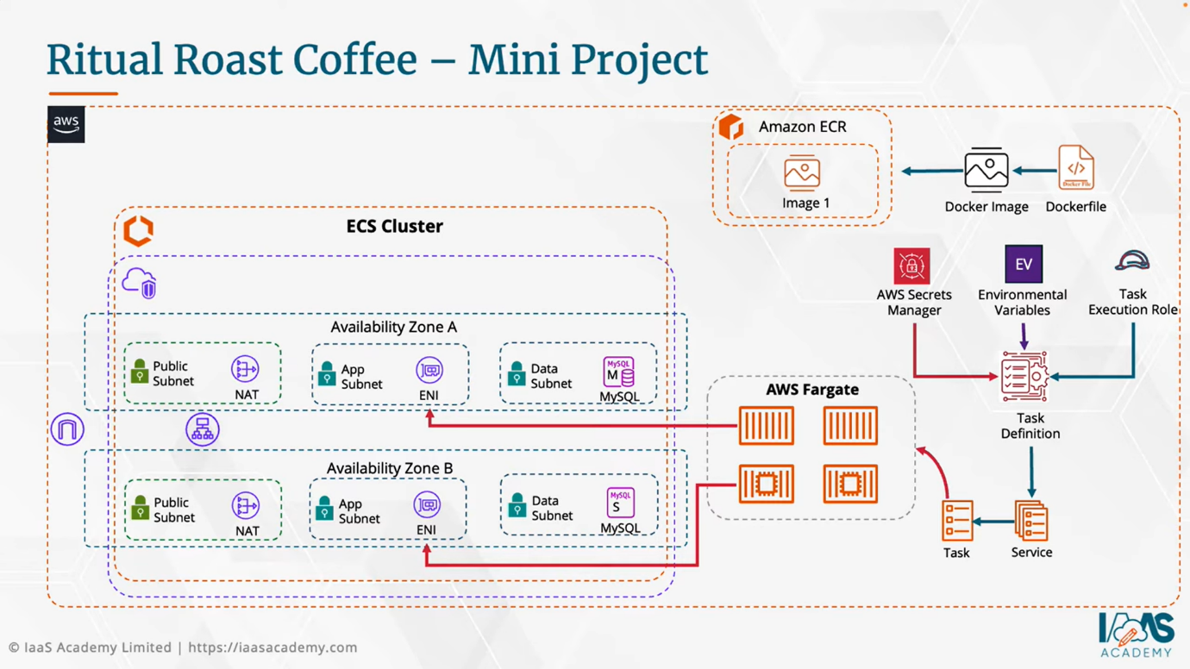

**🡺Step 1 - Build a VPC(North-Virginia)**

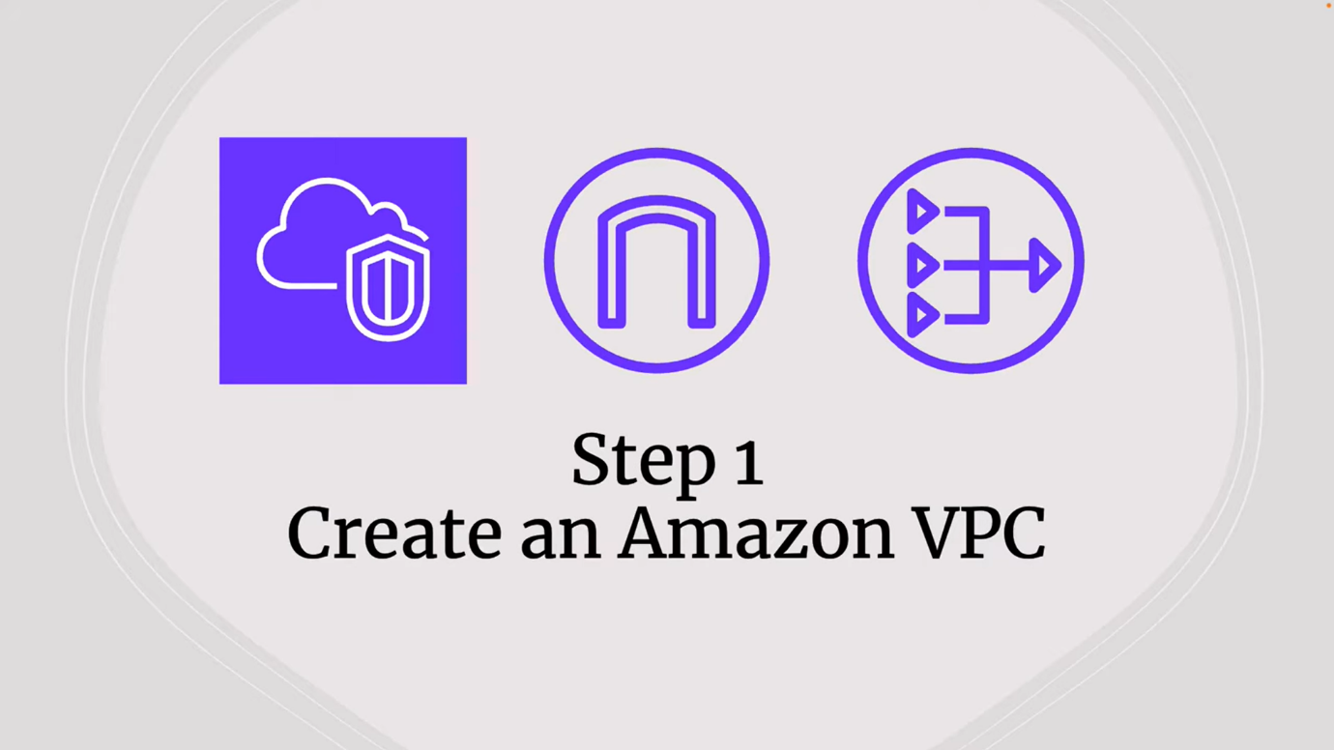

* Resource to create: VPC and More
* Name tag auto-generation: Uncheck
* Number of Availability Zones (AZs) is 2
* Number of Public Subnets is 2
* Number of Private Subnets is 4 (2 App and 2 Database)
* NAT Gateways is 1
* VPC Endpoints is None (Because for the practice purpose only)
* Create VPC

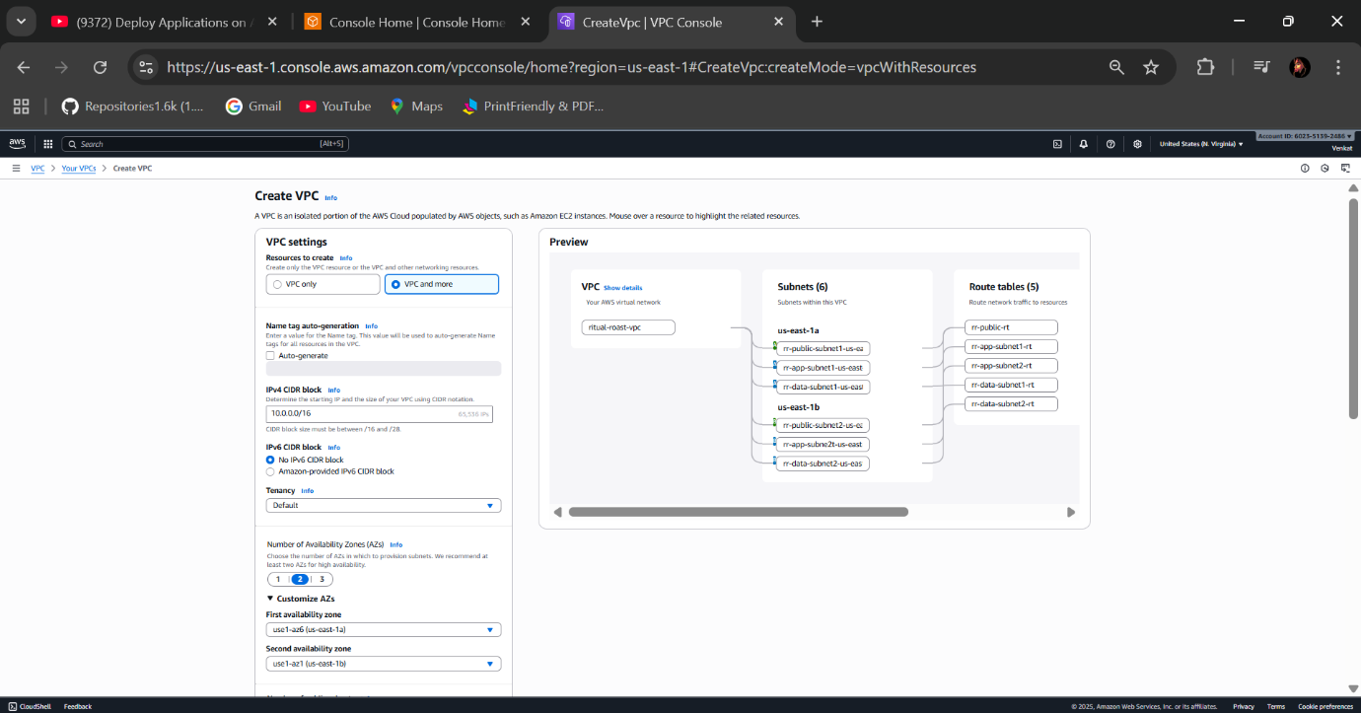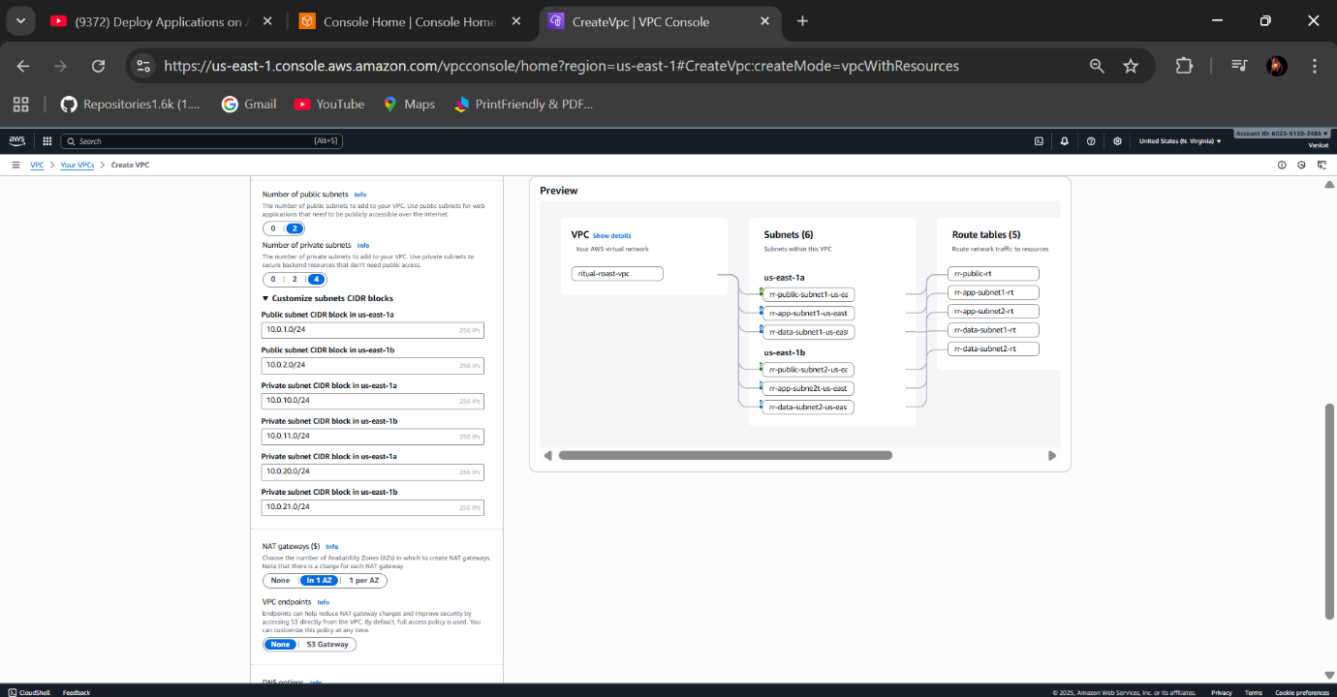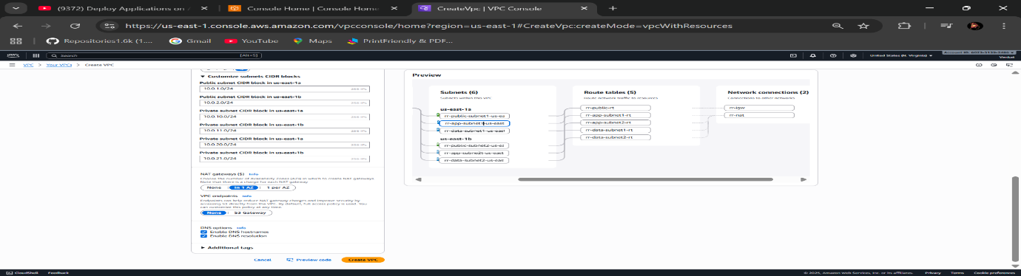

* VPC Created Successfully

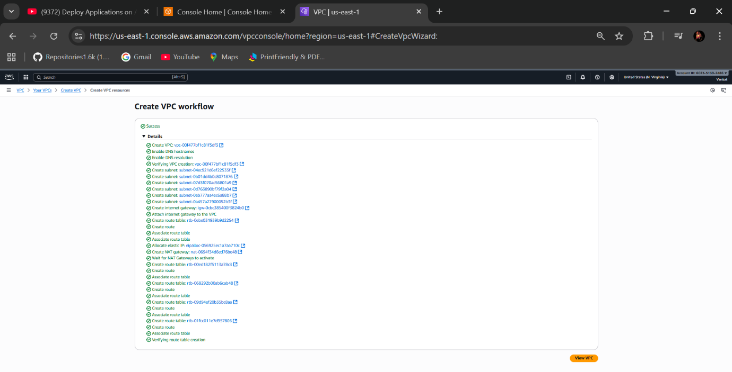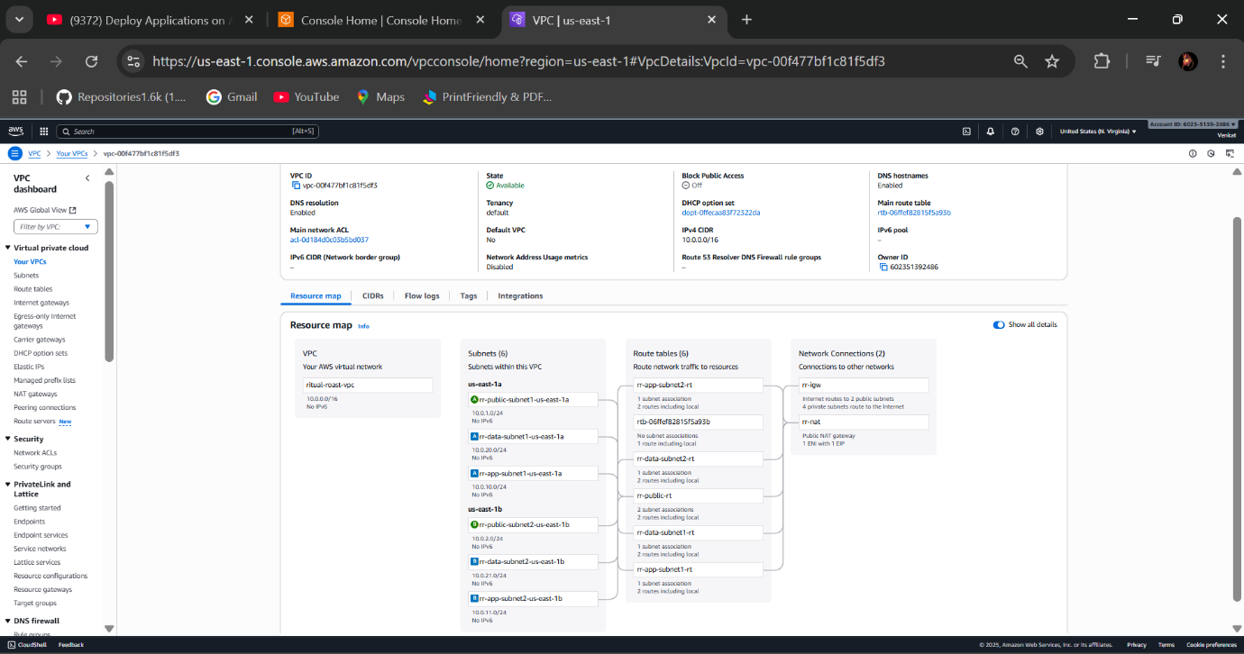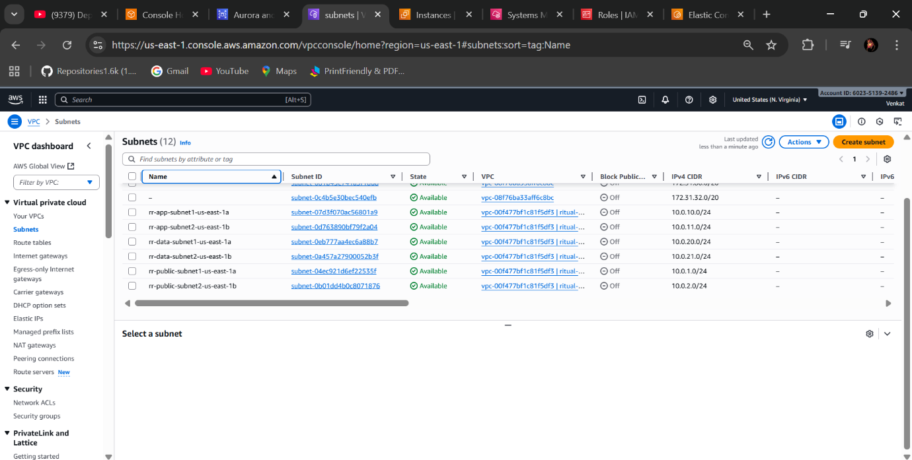

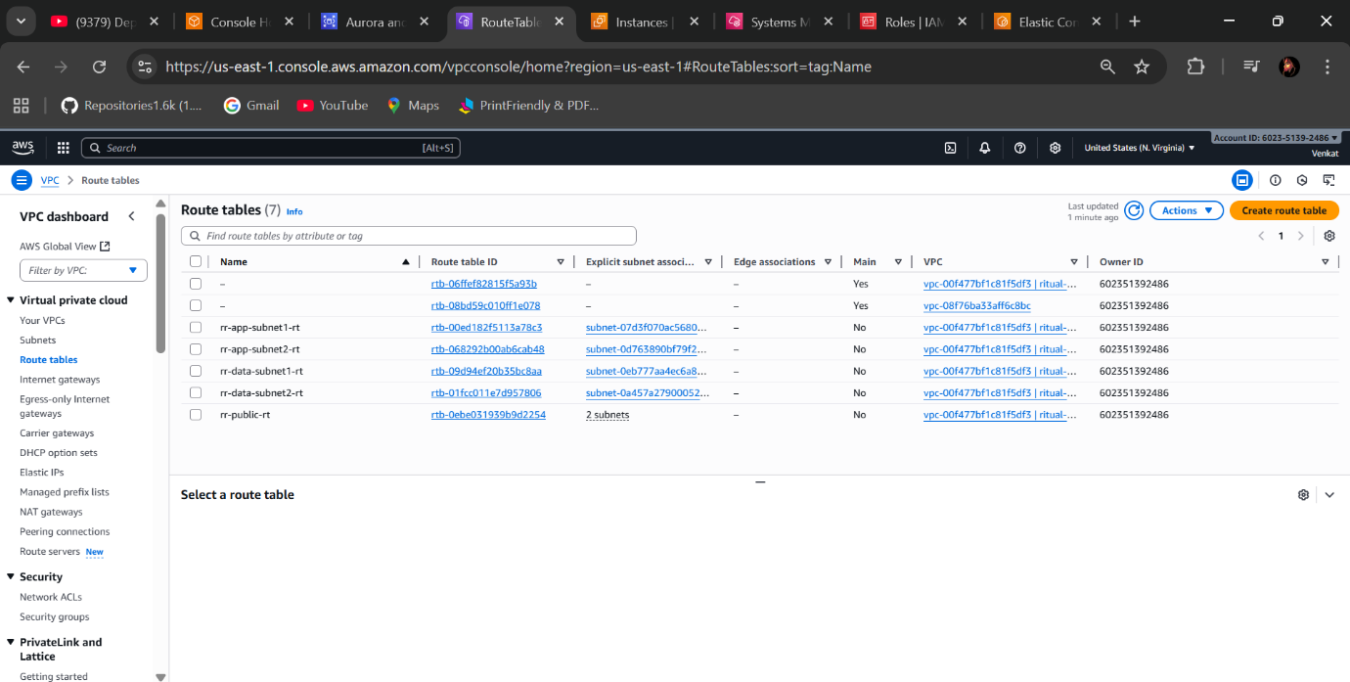

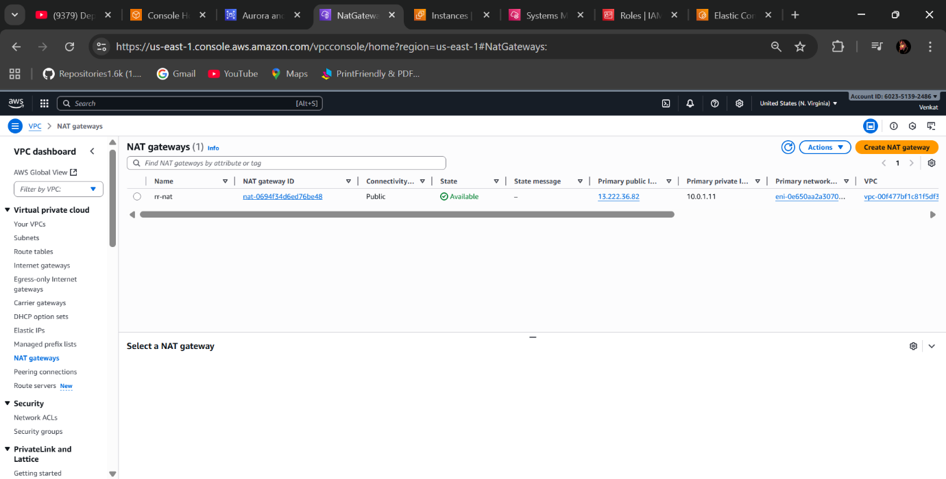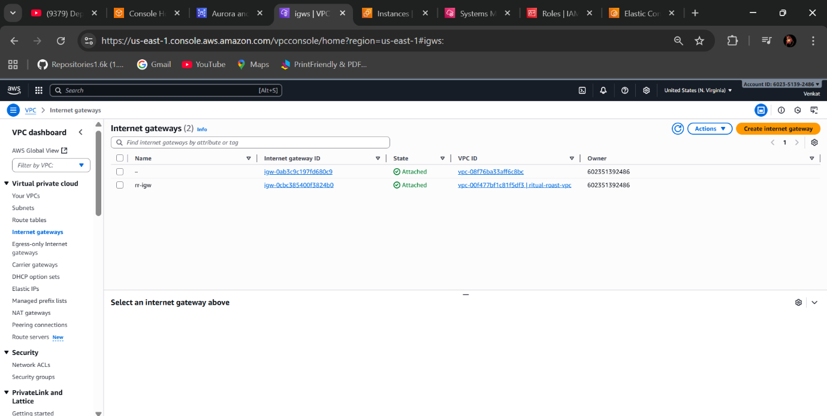

* Create Security Groups of three
* One for Application Load Balancer (rr-alb-sg) and attach VPC & Allow inbound rule HTTP Anywhere
* One for Application (APP) attach the previous ALB security group to it (rr-app-sg) and attach VPC & Allow inbound rule HTTP Custom, attach previous (rr-alb-sg)
* One for Database DB (data) attach the previous app security group (rr-data-sg) and attach VPC & Allow inbound rule MYSQL/Aurora Custom, (rr-app-sg)

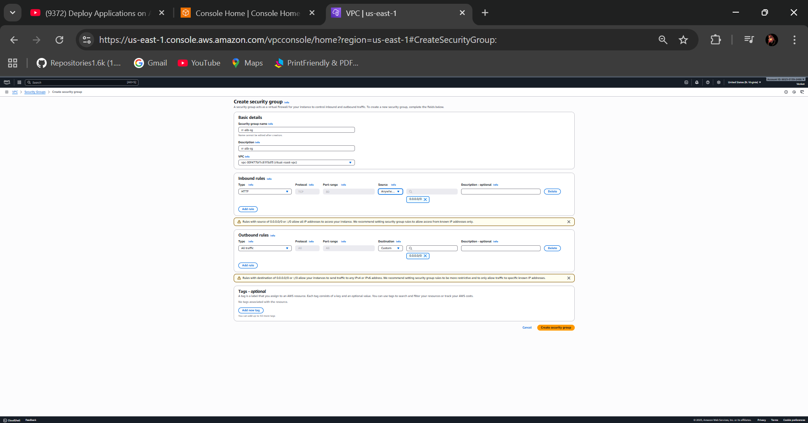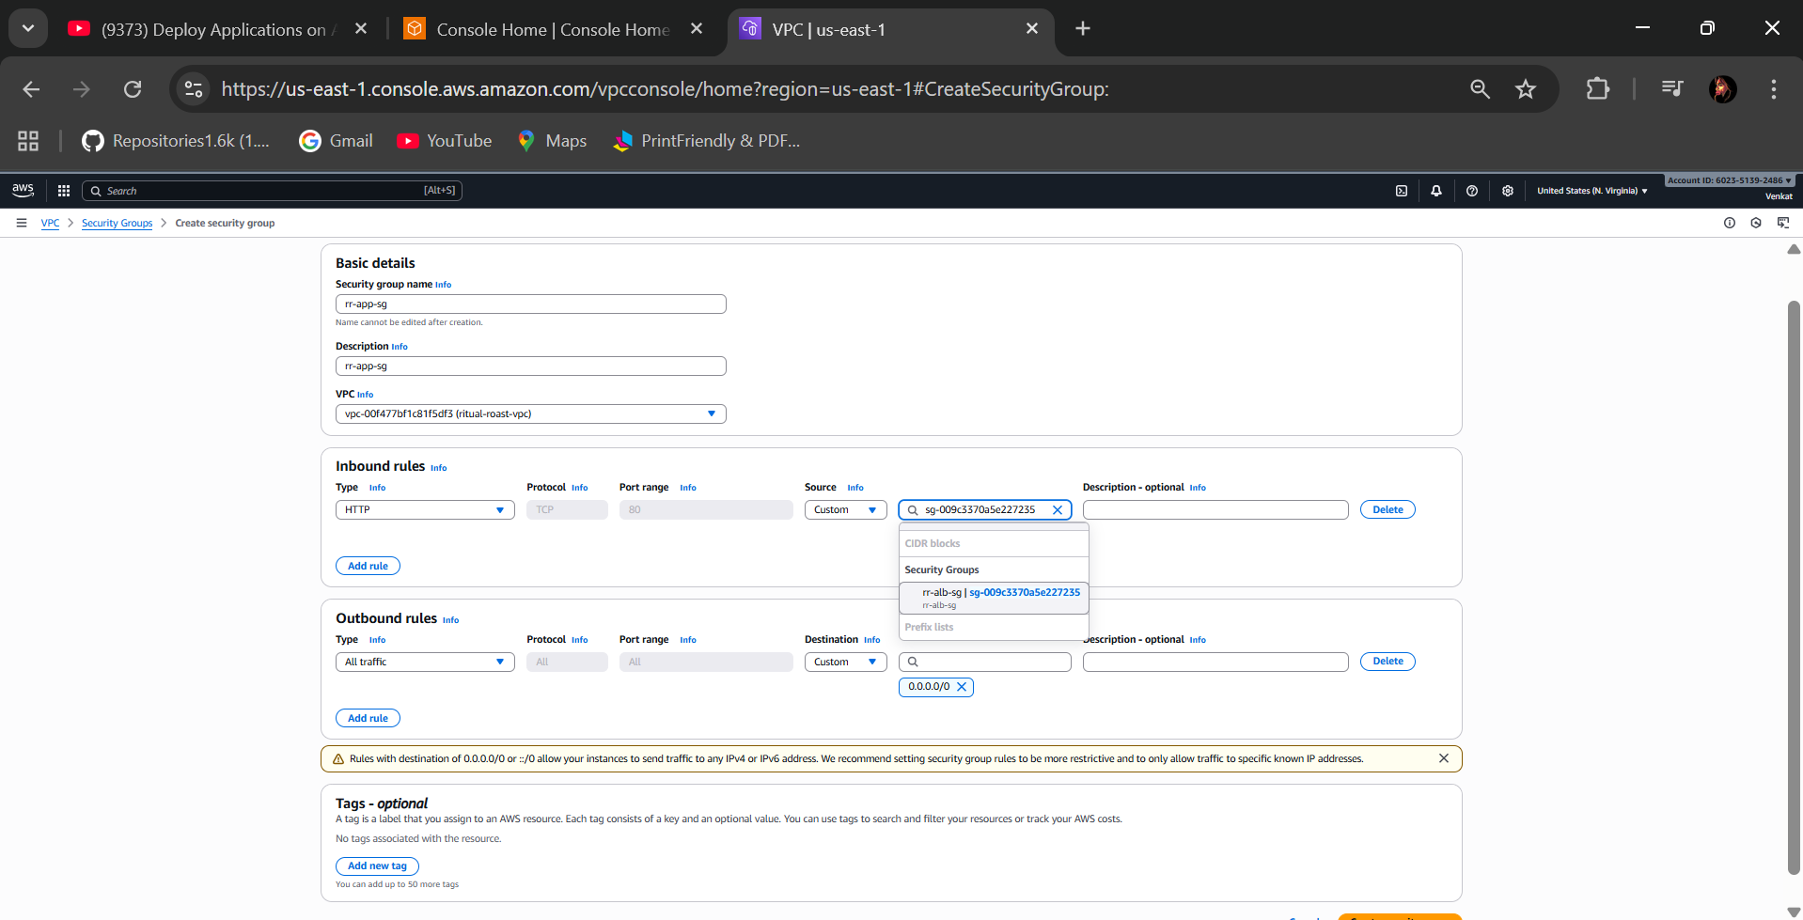

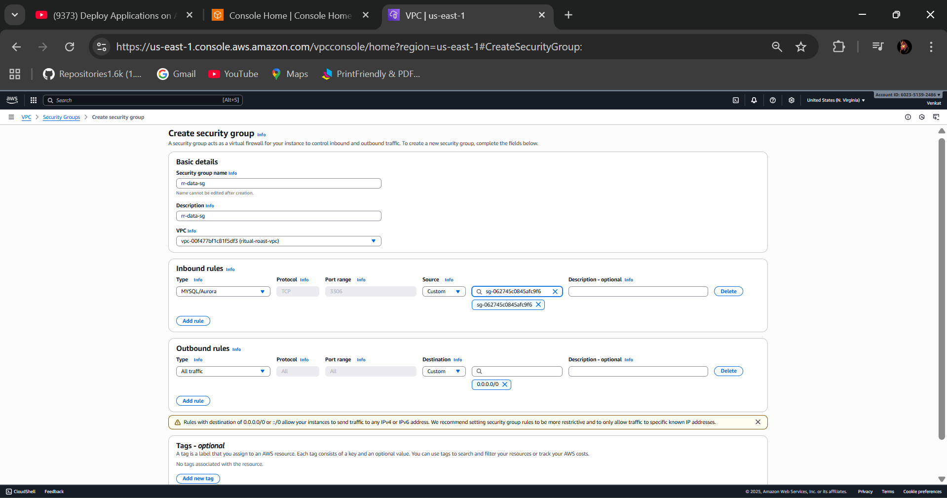

* Created three Security Groups Successfully

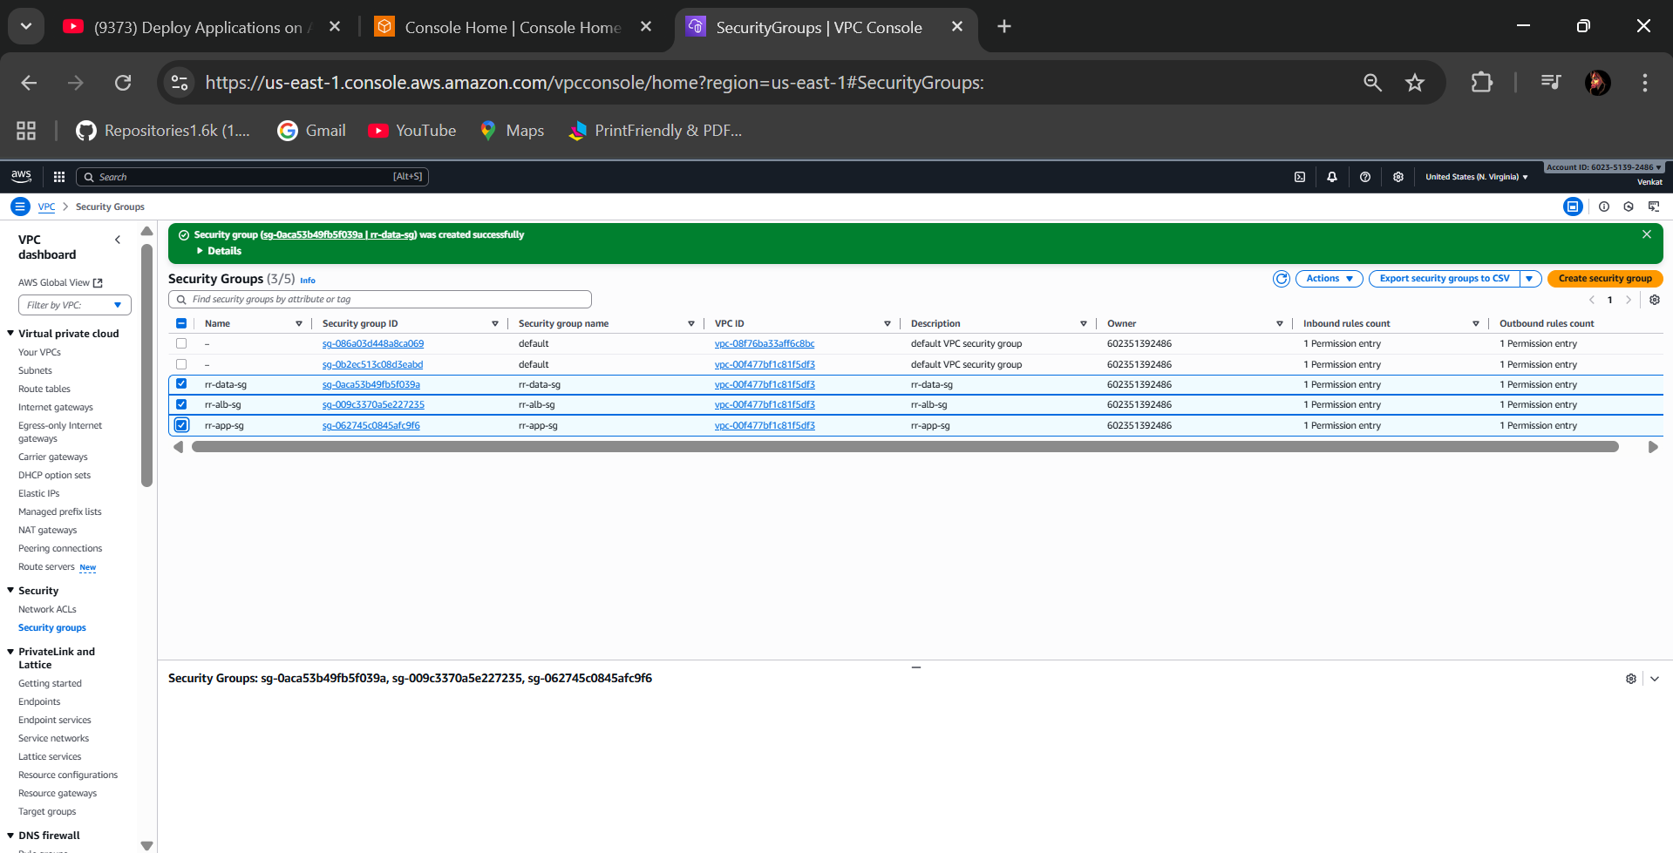

**🡺Step 2 - Create an Amazon ECR Repository**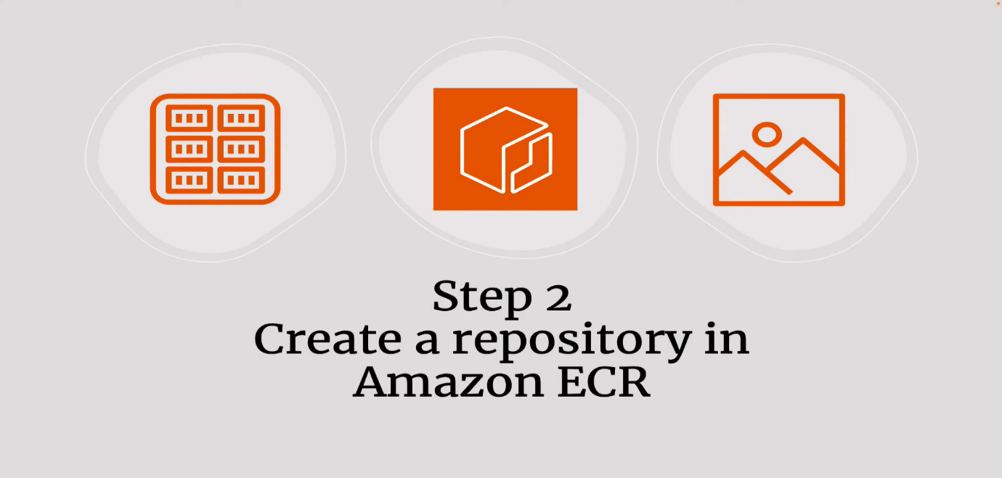

* Create ECR Repository in the AWS Console

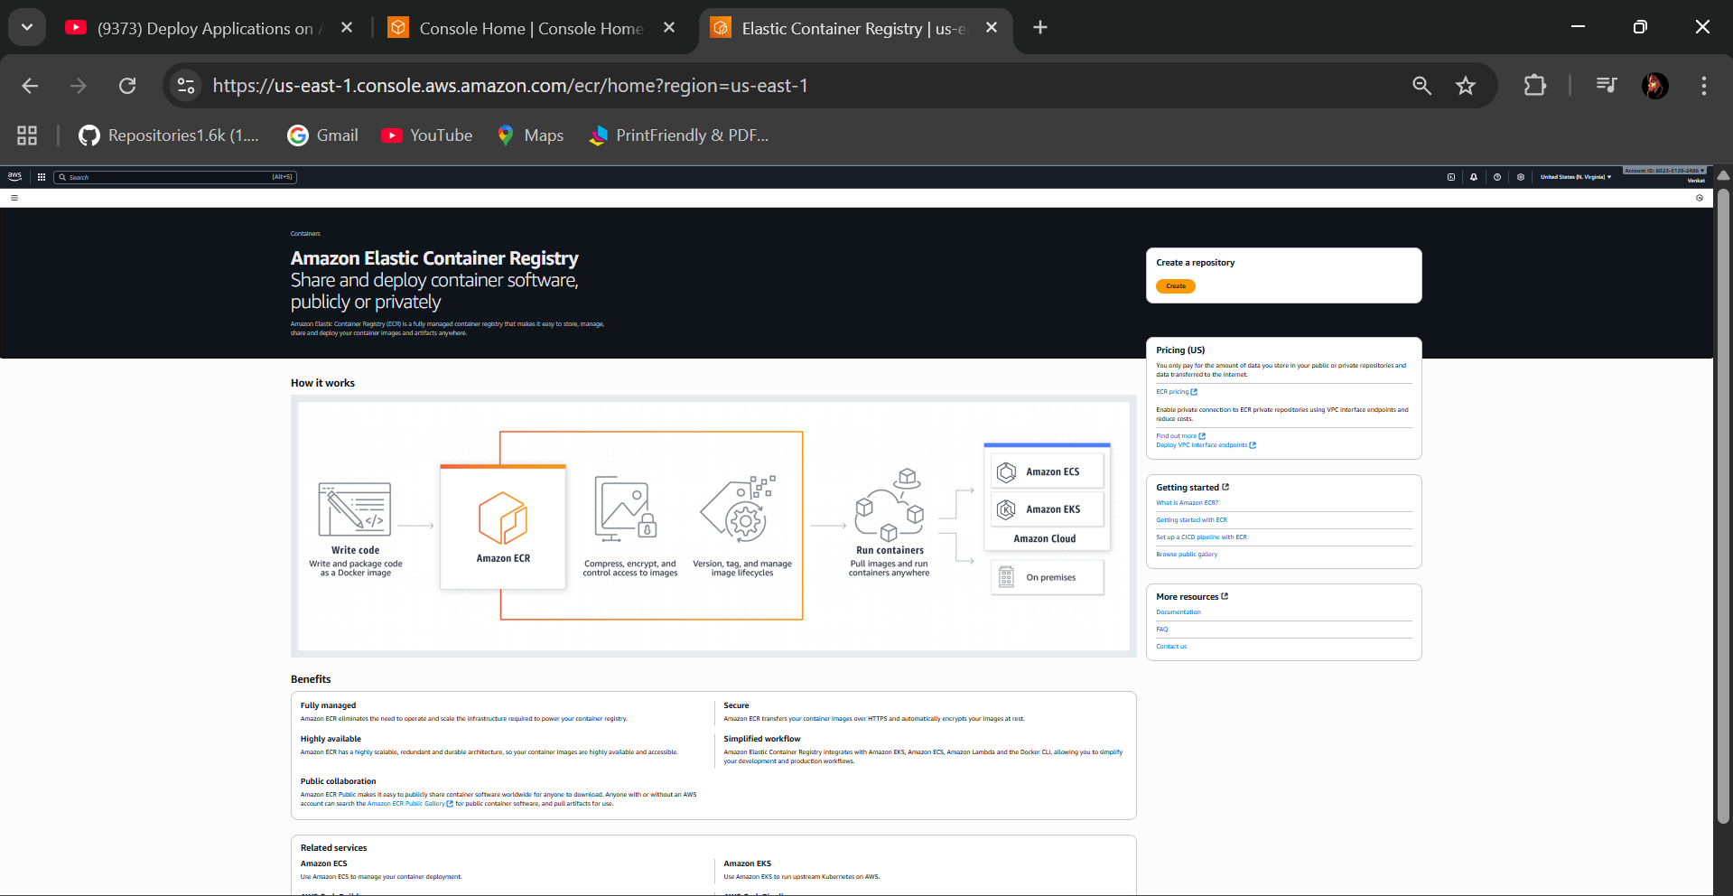

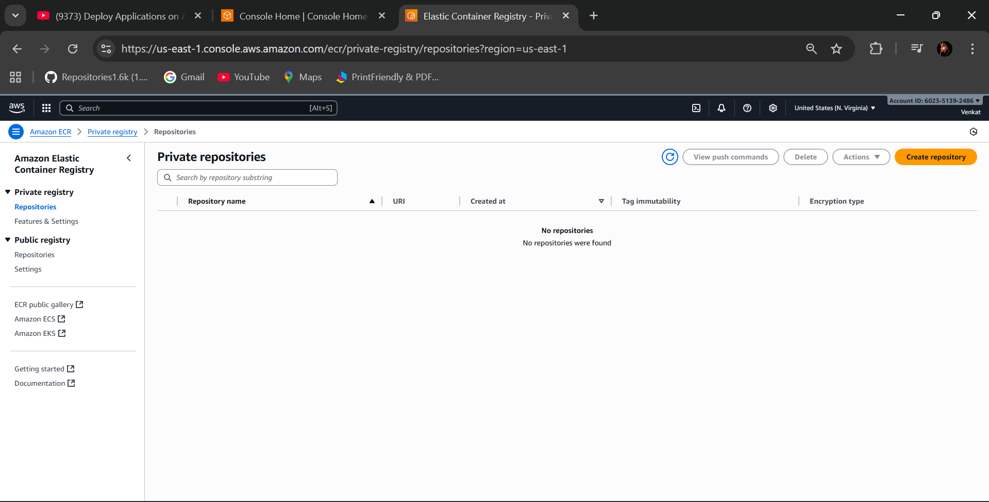

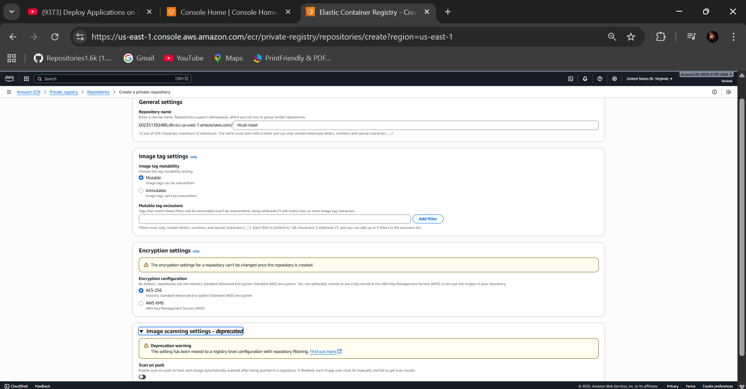

* Create it

**🡺Step 3 - Build a Docker Image**

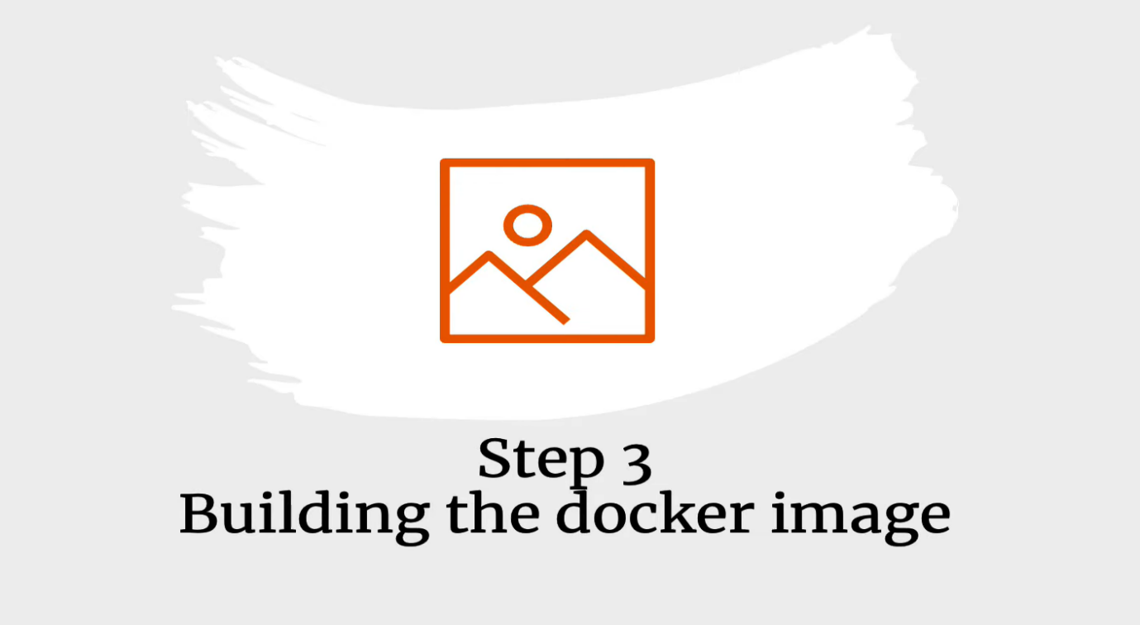

* Download the Docker Desktop in your laptop and AWS CLI using IAM user optional

**IAM Permissions:**

* Create IAM role for giving permissions of session manager and ECR
* Like SSM managed instance core and EC2 instance profile for image builder ECR container builds.

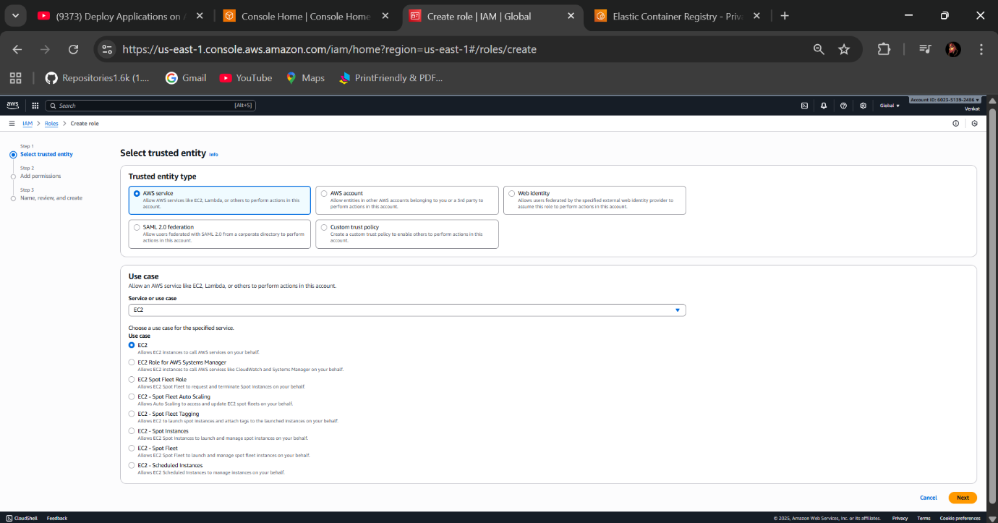

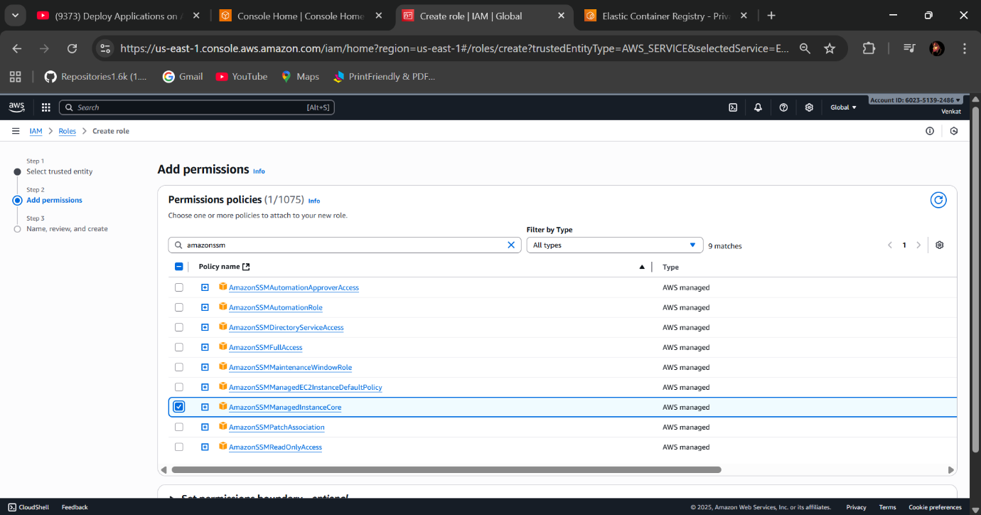

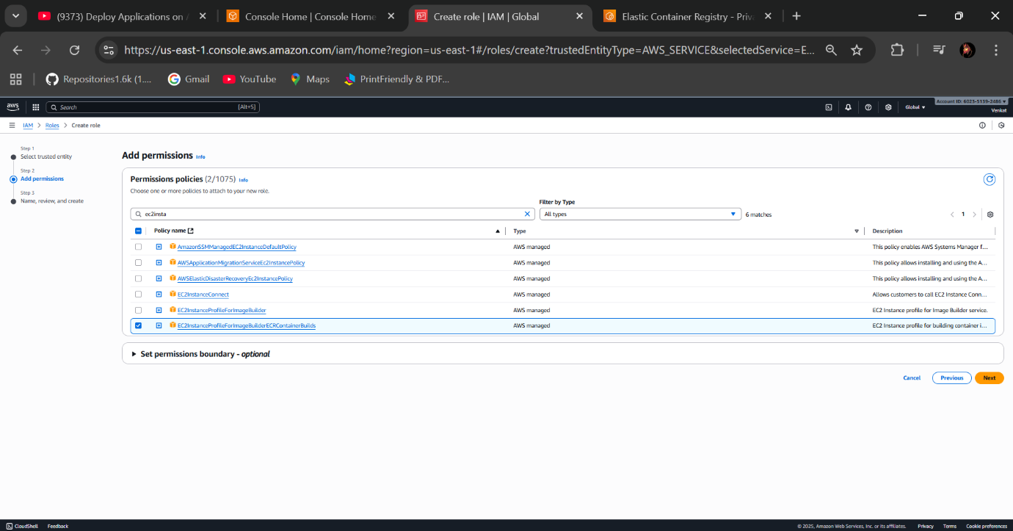

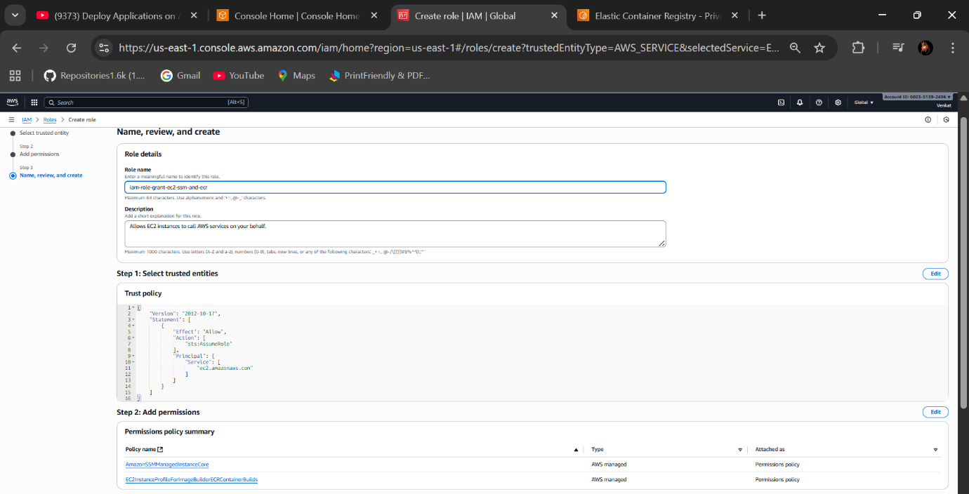

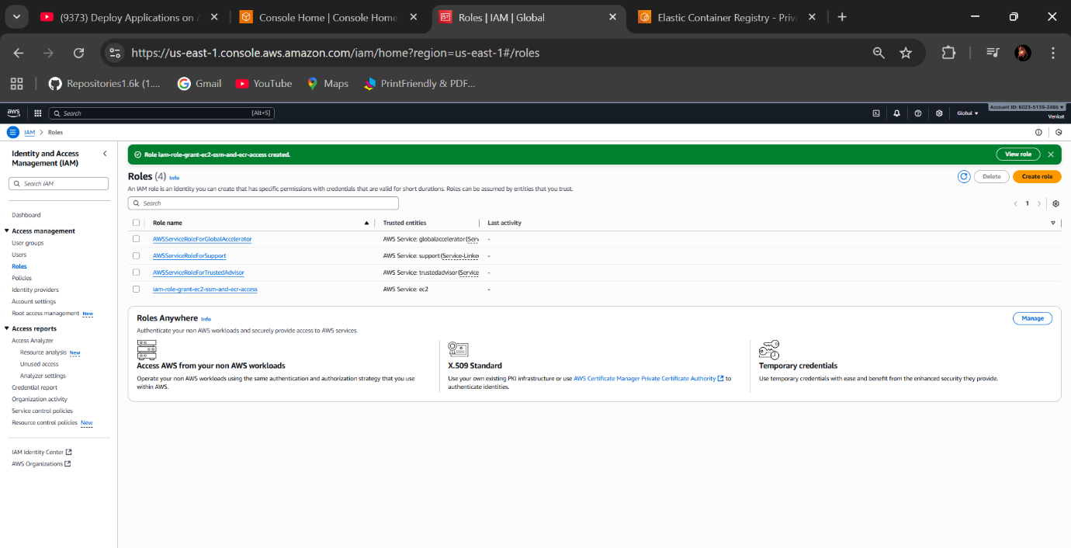

**EC2 Instance:**

* Launch EC2 Instance

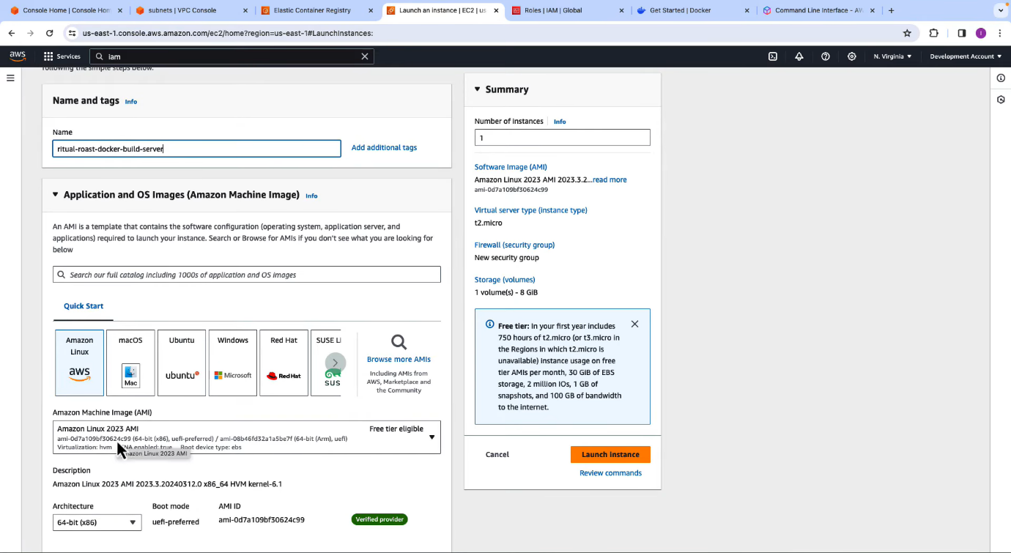

* Proceed without key pair because, I were using Session manager
* Select your created VPC, Subnet (app.subnet-1) and allow existing Security group “default”

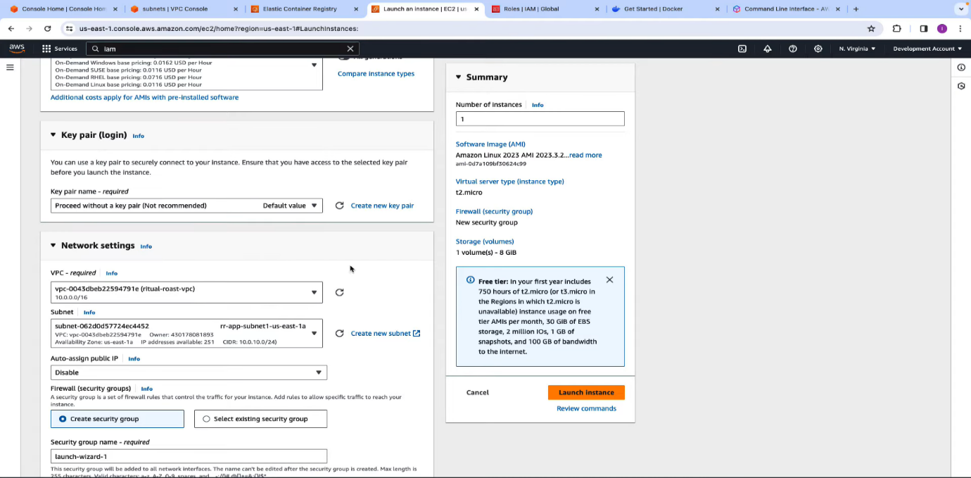

* Select your IAM Instance profile whatever you created in the previous

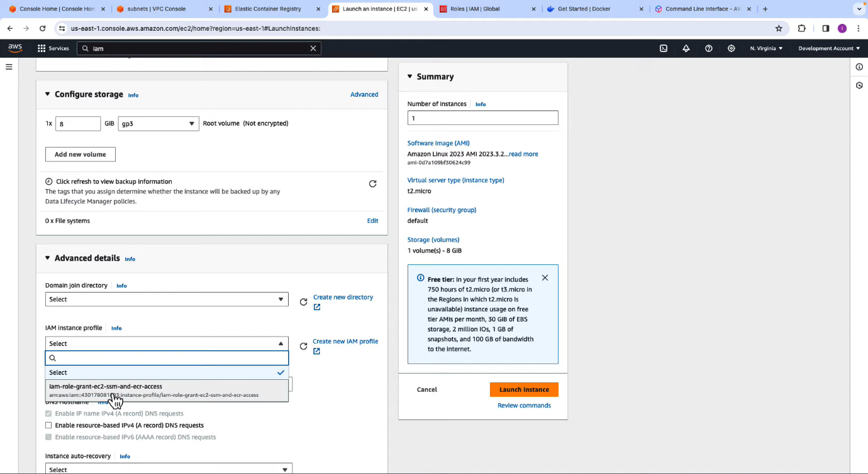

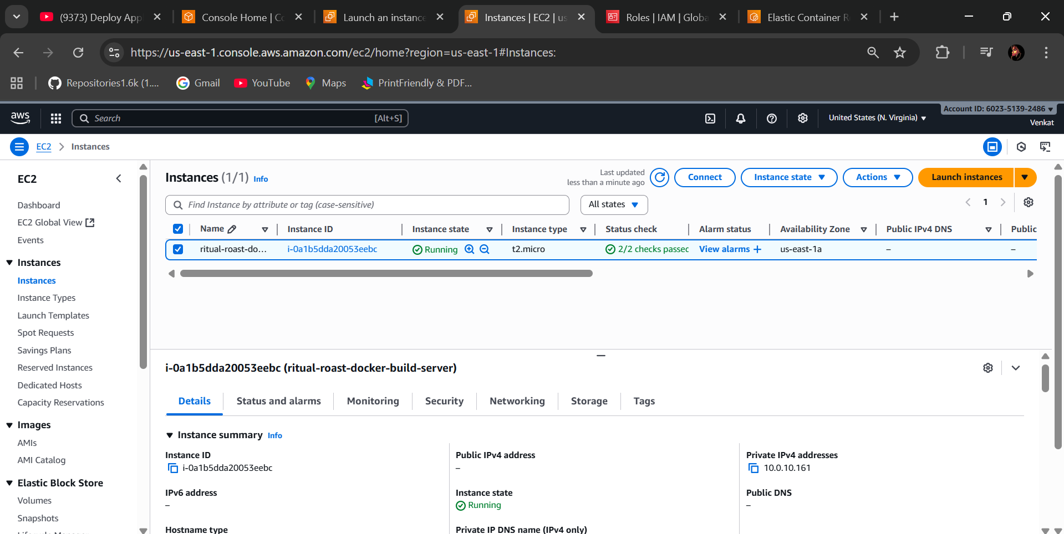

* Select Launch Instance
* Connect through Session manager in the terminal type to connect EC2 user (sudo su - ec2-user)
* sudo yum update -y
* sudo yum install docker -y
* sudo service docker start
* sudo usermod -a -G docker ec2-user
* exit and reconnect with (sudo su – ec2-user)
* wget <https://github.com/iaasacademy/aws-how-to-guide/raw/refs/heads/main/amazon-ecs-mini-project/ritual-roast-code.zip>
* unzip it

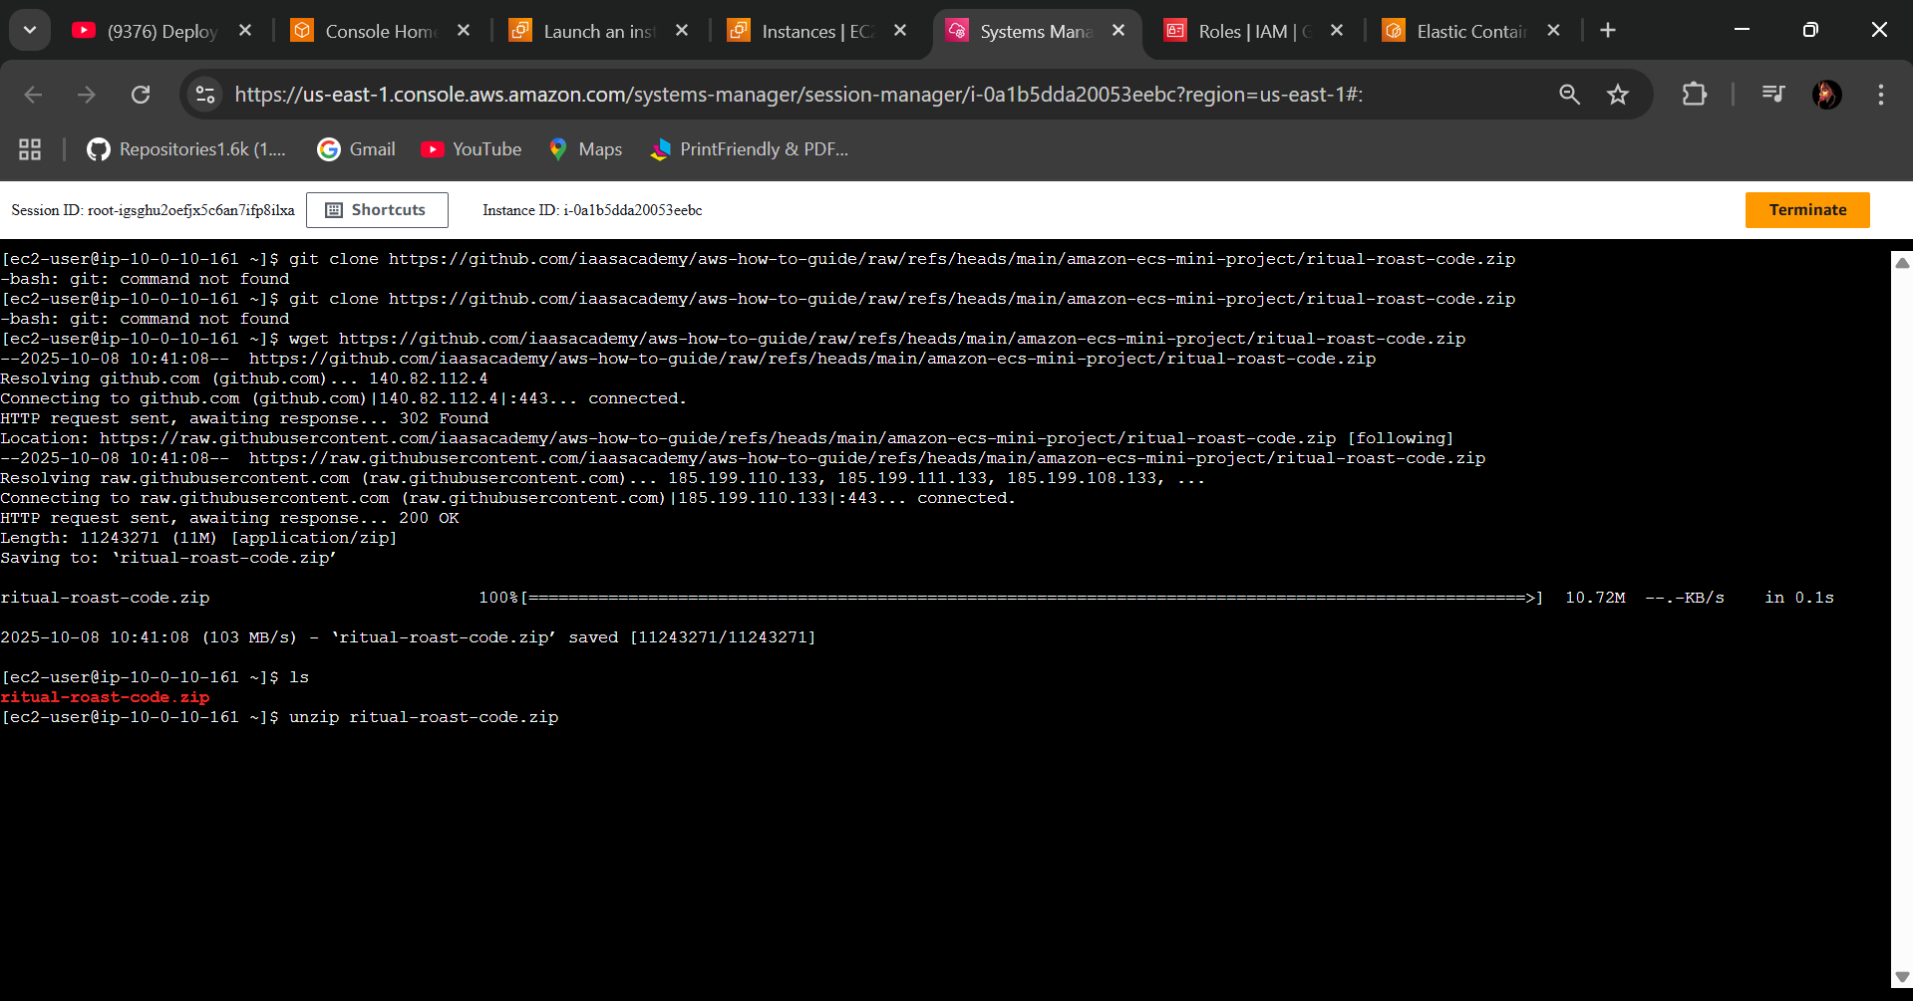

* cd ritual-roast-code/
* Here, I am moving docker container like Dockerfile🡪Docker Image moving to the ECR Repository

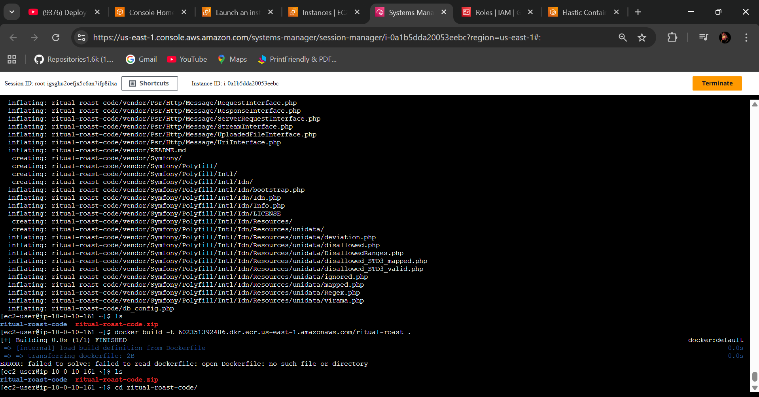

* docker build -t <ECR Repository URL> .

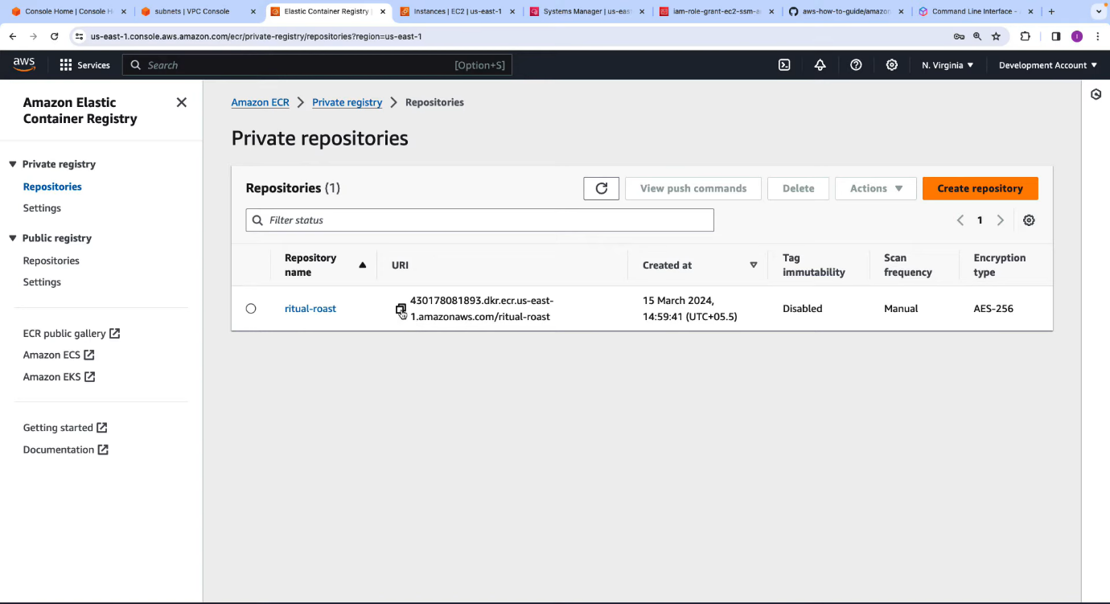

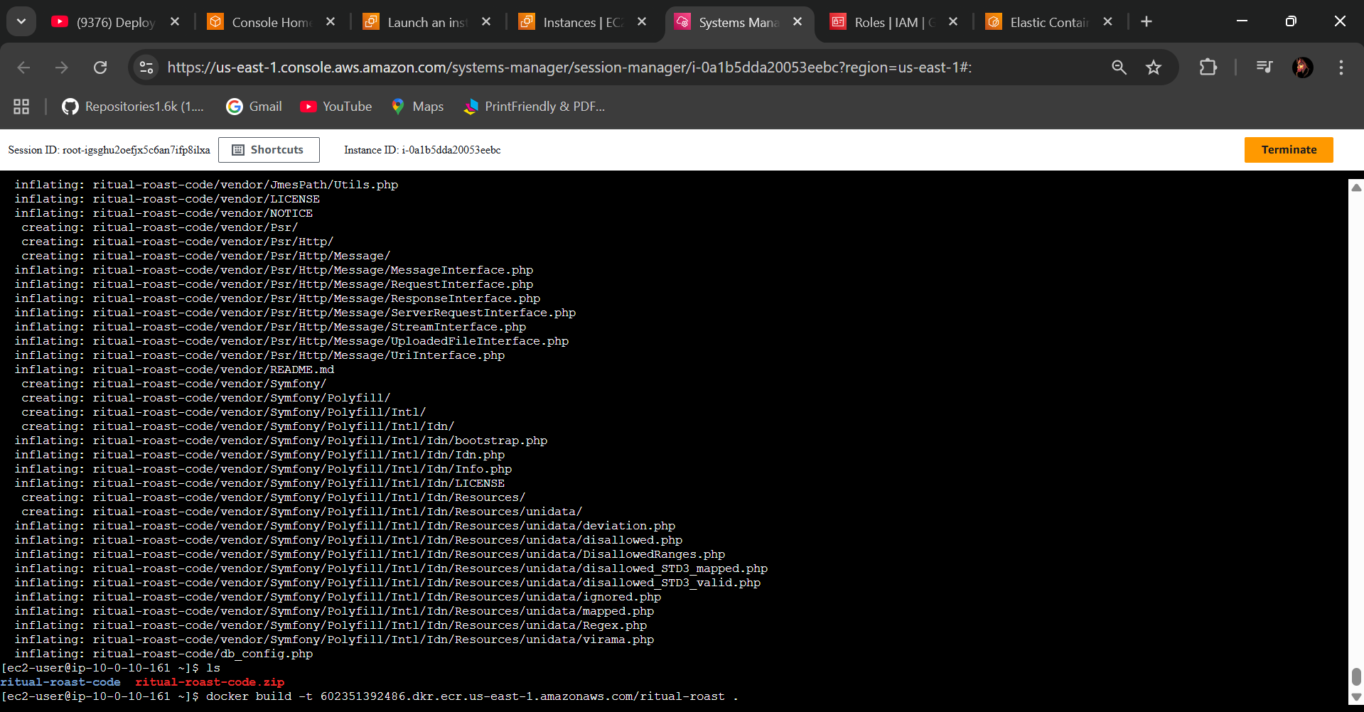

* docker image is created

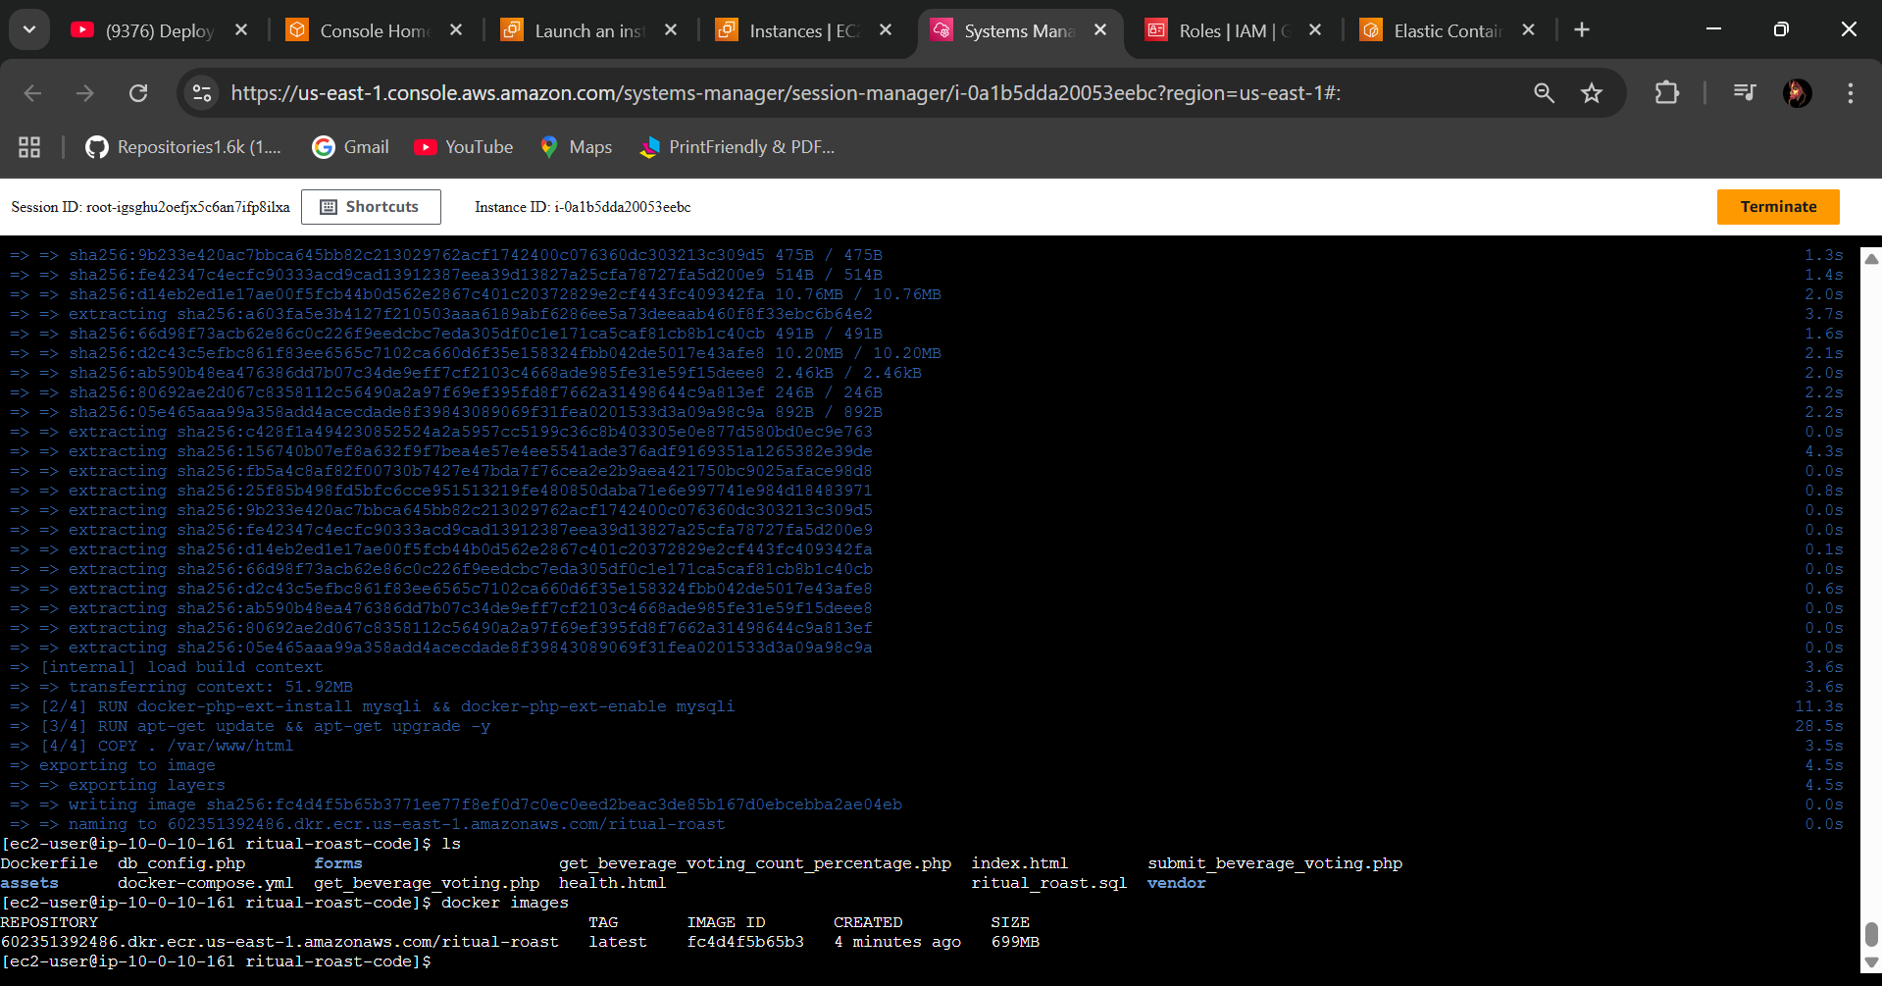

**🡺Step 4 - Push Docker Image to Amazon ECR**

* From the above we created through Dockerfile created docker image
* Go to the ECR repository select view push commands and run those four

commands whatever you seen in it.

* Run 1 and 4 commands because you already 2 and 3 and executed previous
* So here successfully Moved docker image into the ECR Repository refresh and check it in ECR

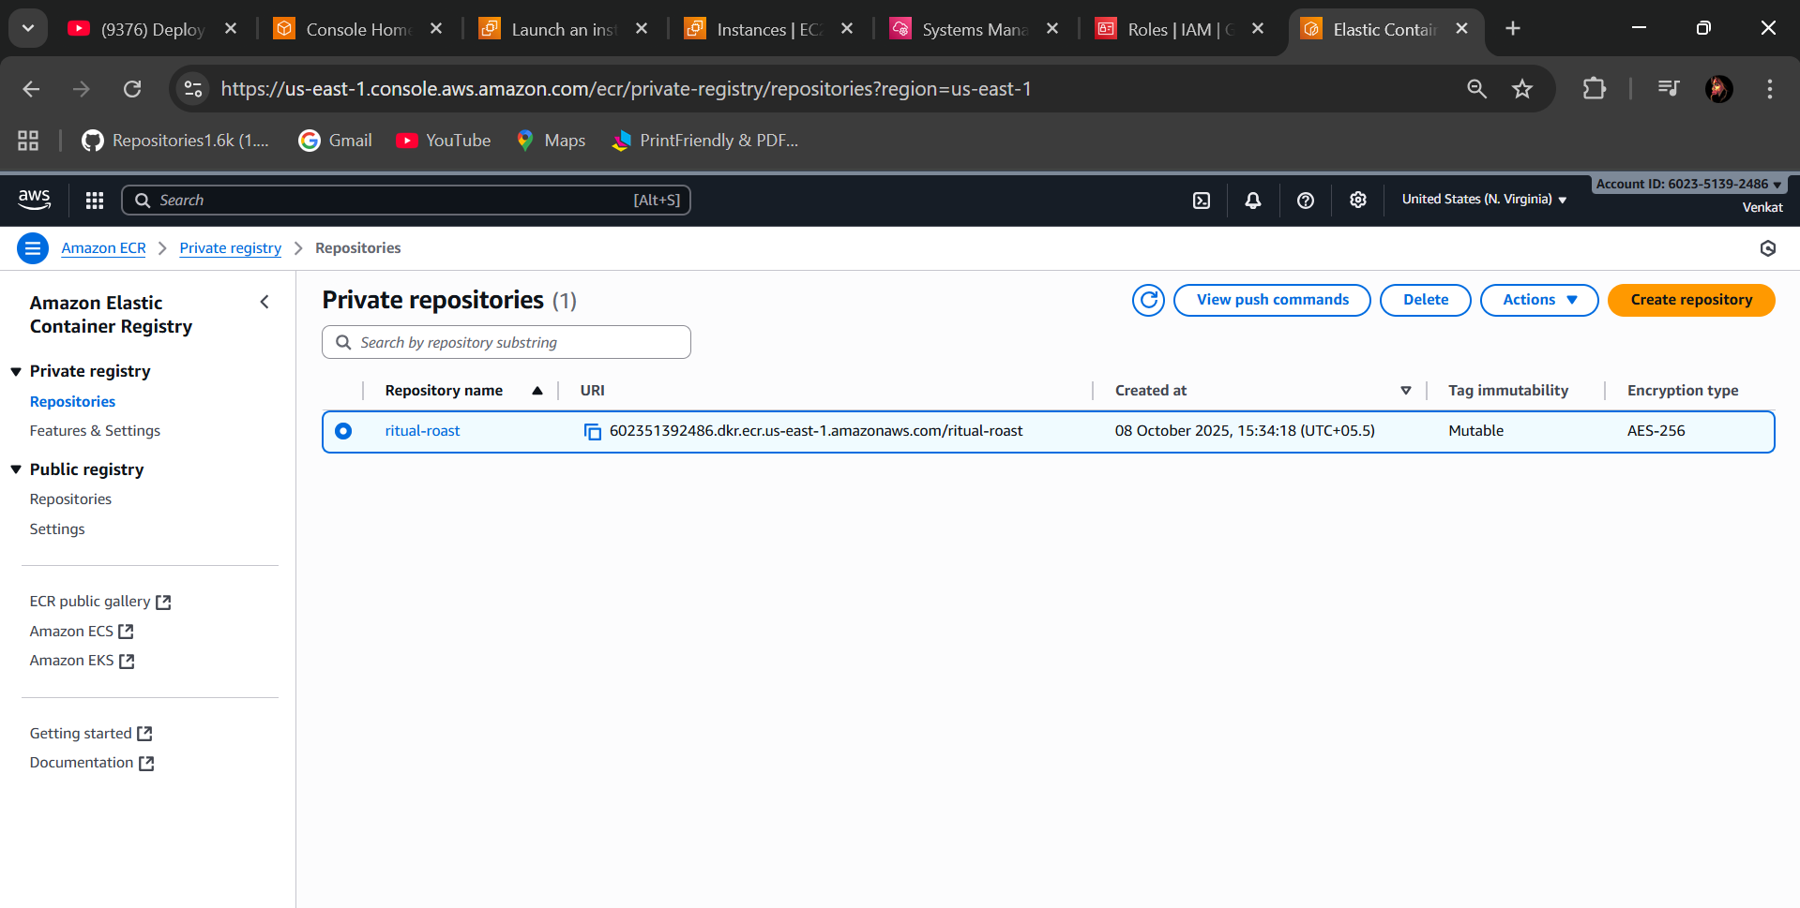

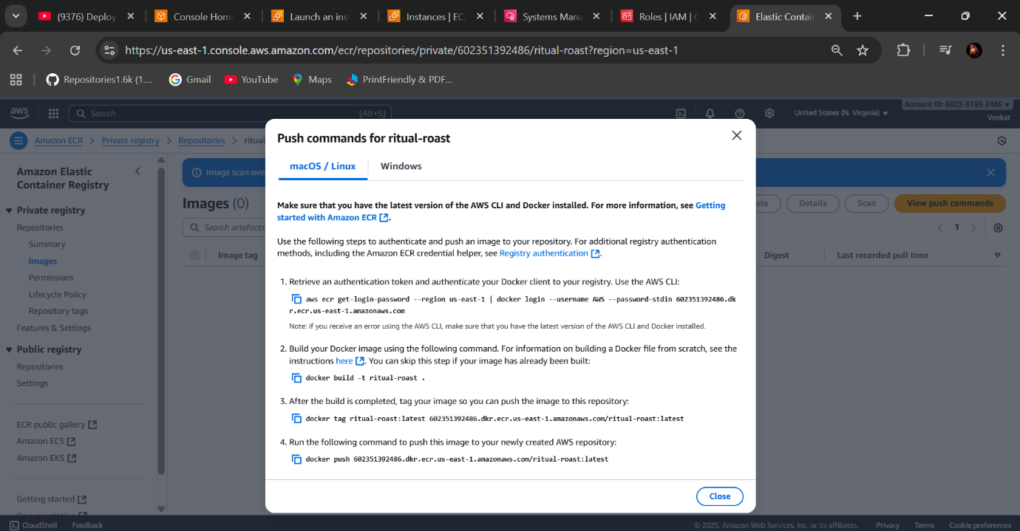

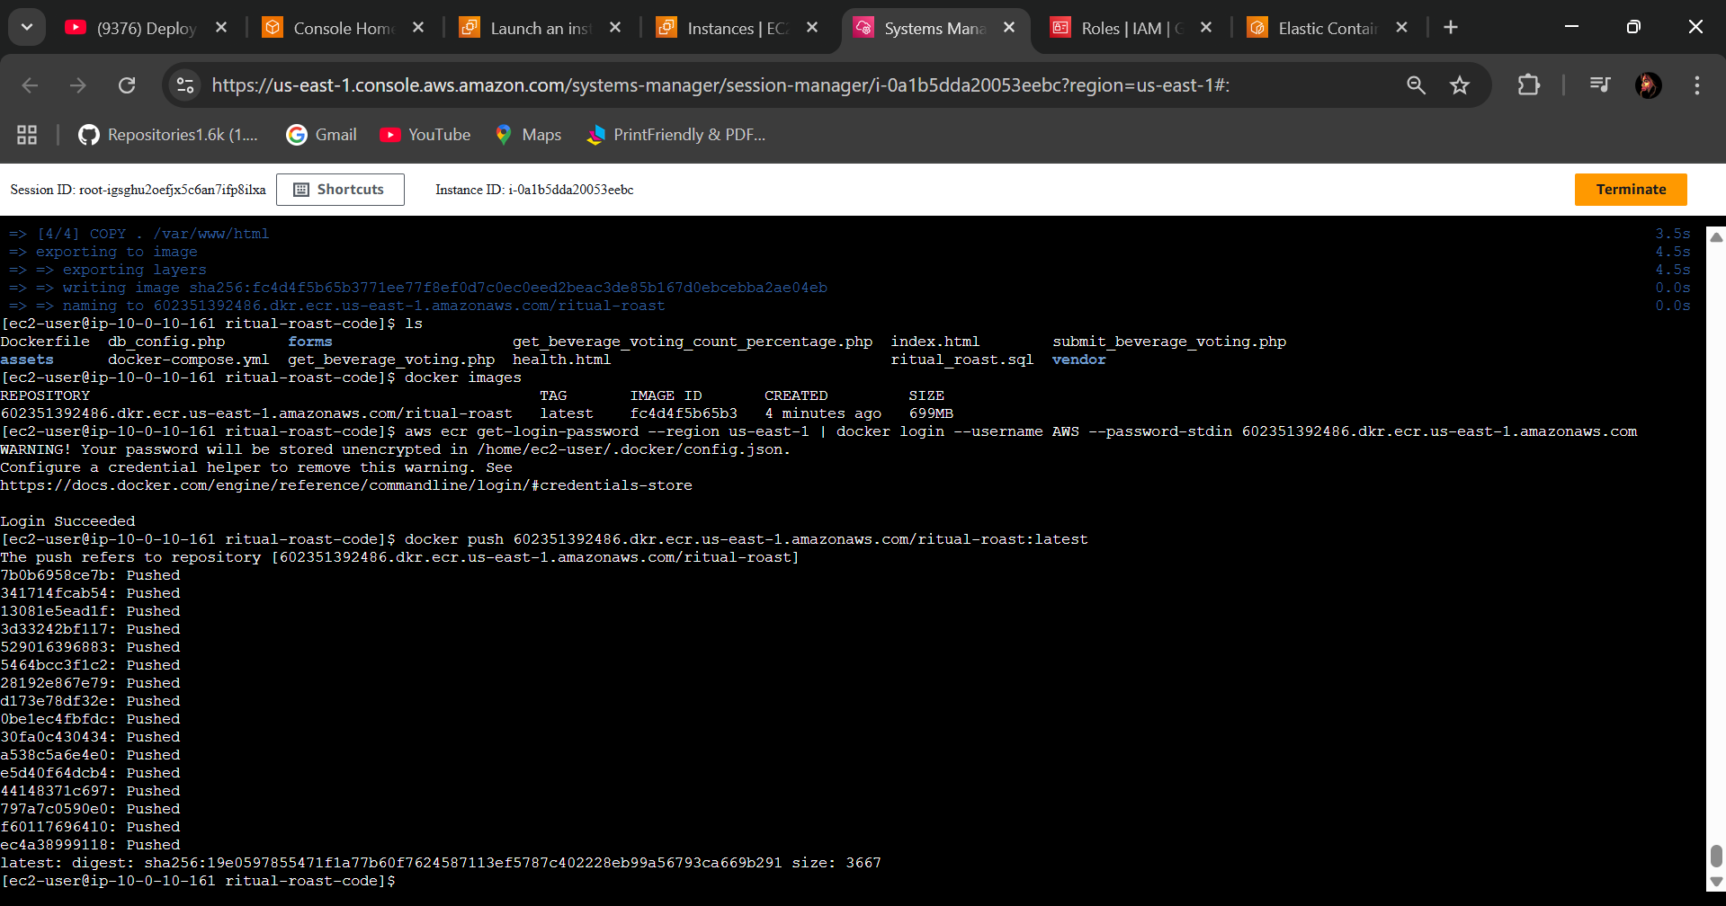

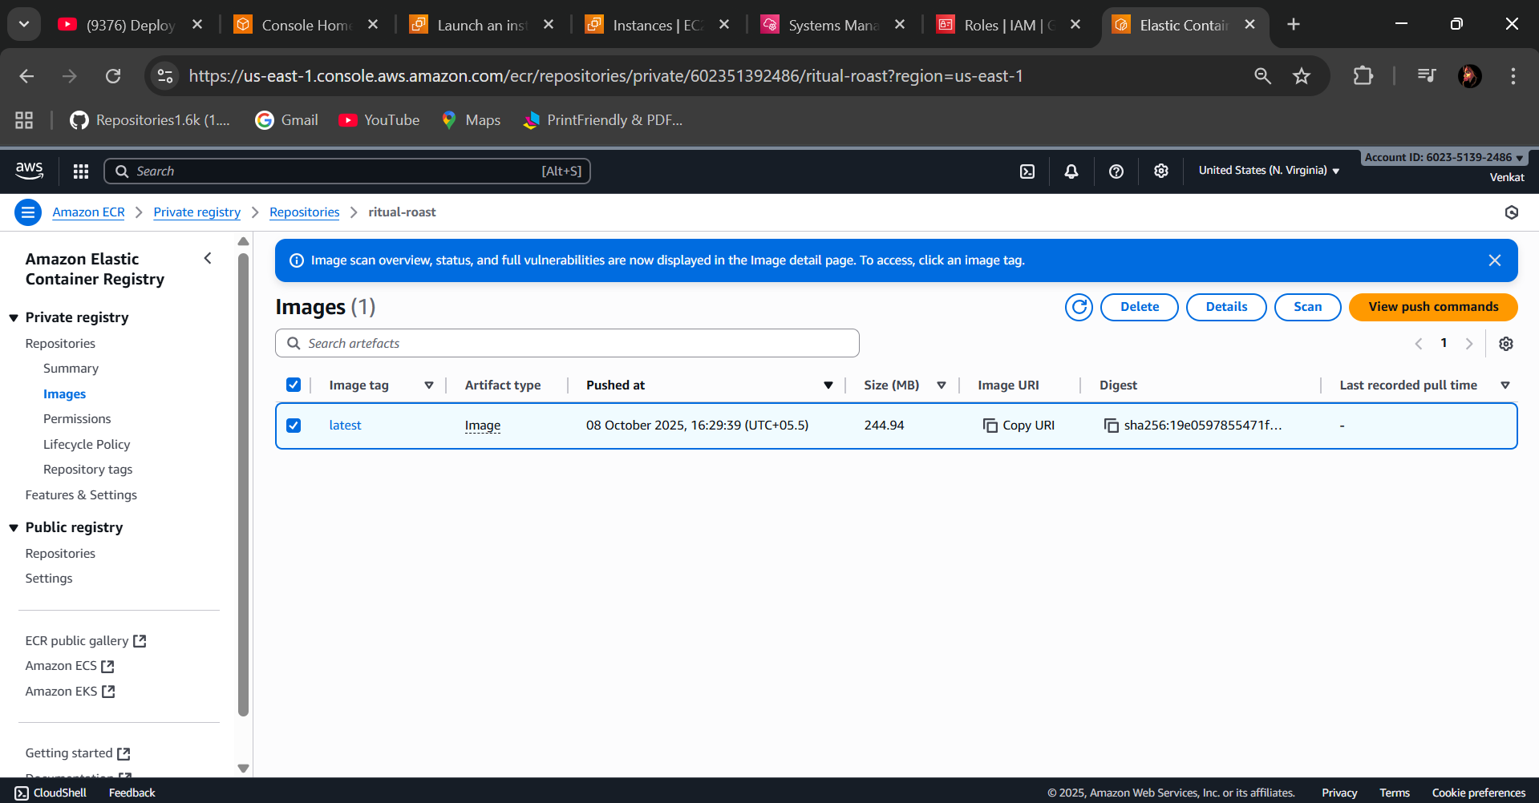

**🡺Step 5 - Create an Amazon RDS Database**

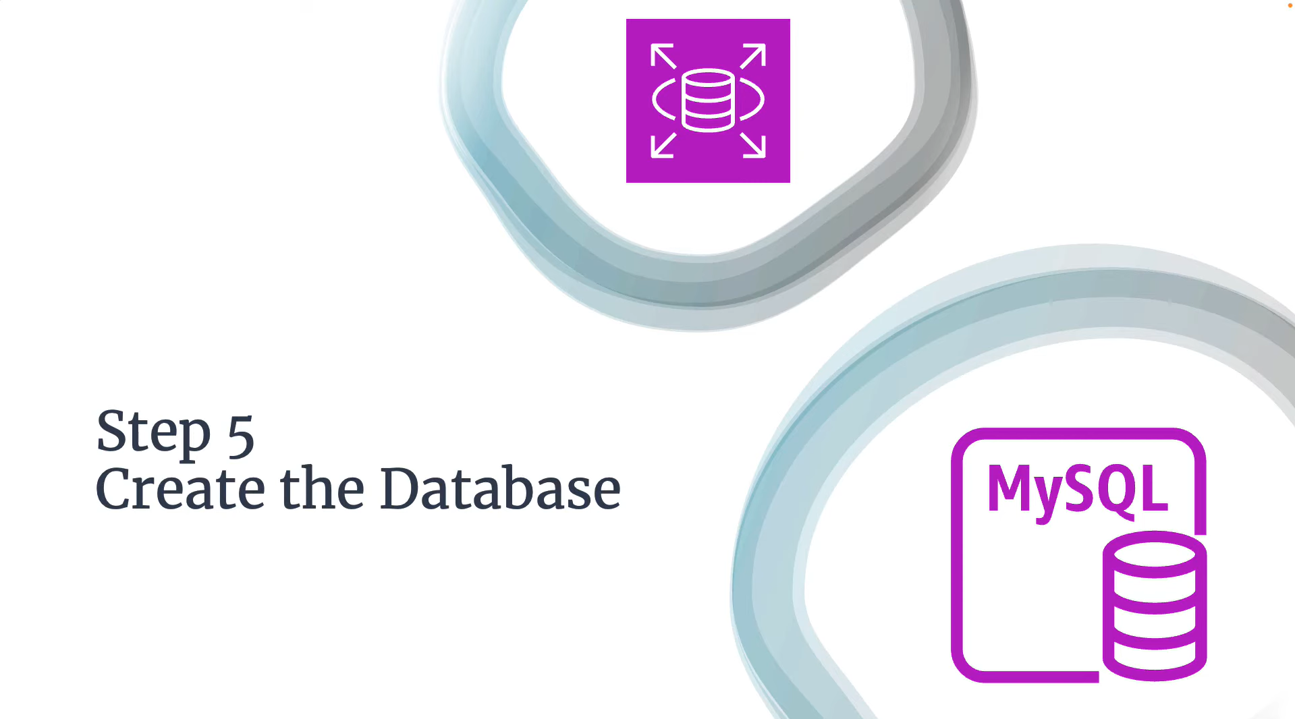

* In the RDS Database go to Subnet Groups add Availability Zones & Select Database Subnets (rr-data-subnet) cross check from your previous created in the VPC

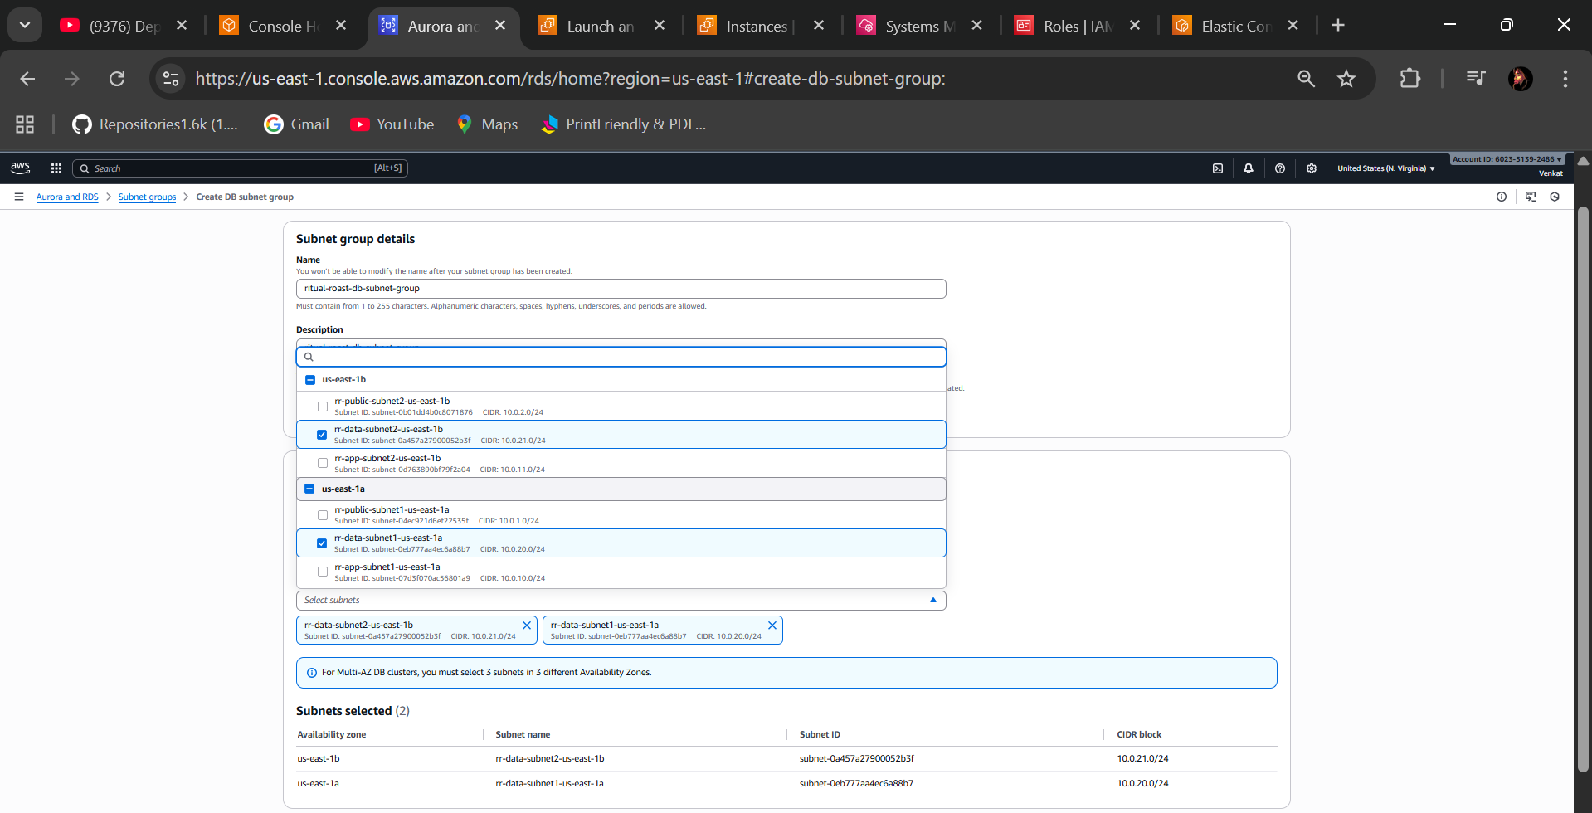

* Create
* Next step Create database in the RDS

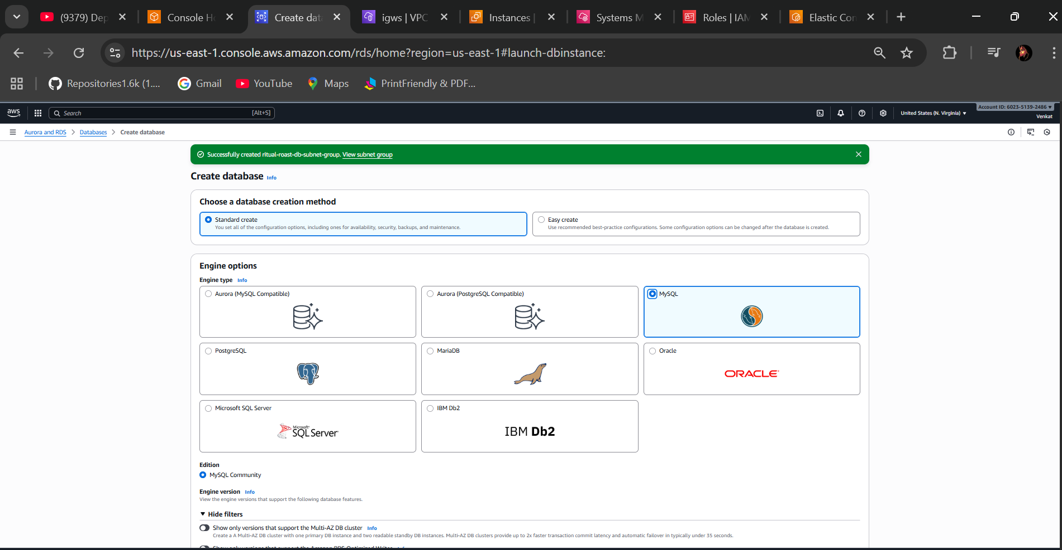

* Select Standard create & Select MYSQL database
* In the Templates Select “free-tier”
* Give the name in the DB instance identifier
* In the credentials settings admin & give password as you wish
* Turnoff the storage Autoscaling
* Select VPC
* Select VPC Security group you created in the previous select it database(rr-data-sg)
* Availability Zones select one zone
* In the additional configurations give the name “ritualroastdb”
* create database

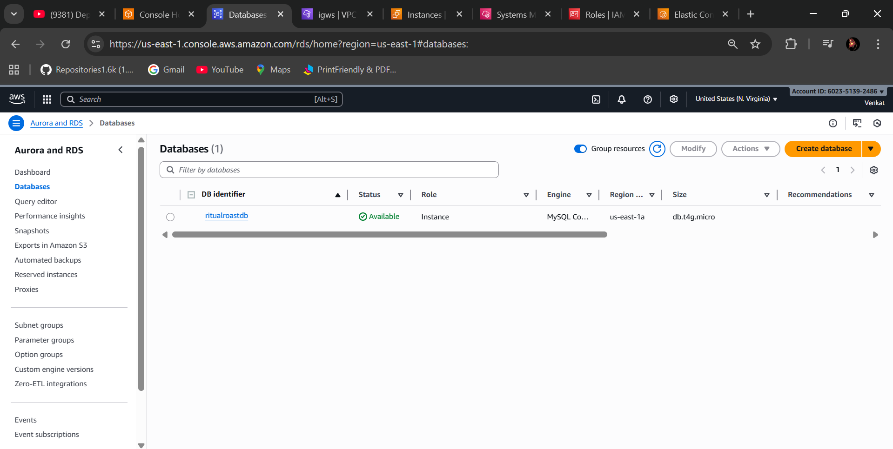

* Created Database Sucessfully

**🡺Step 6 - Configure AWS Secrets Manager**

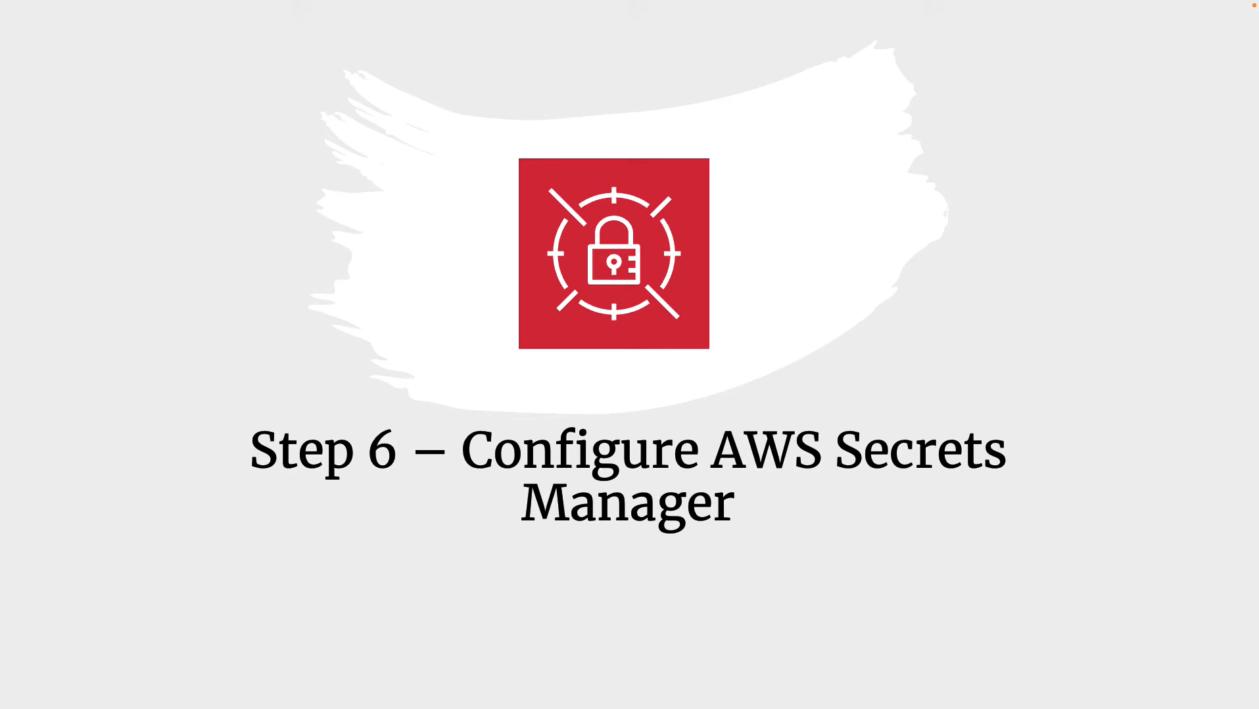

* In the VPC select (rr-data-sg) security group in the inbound rule add the MYSQL/Aurora, custom, select database security group (rr-data-sg)

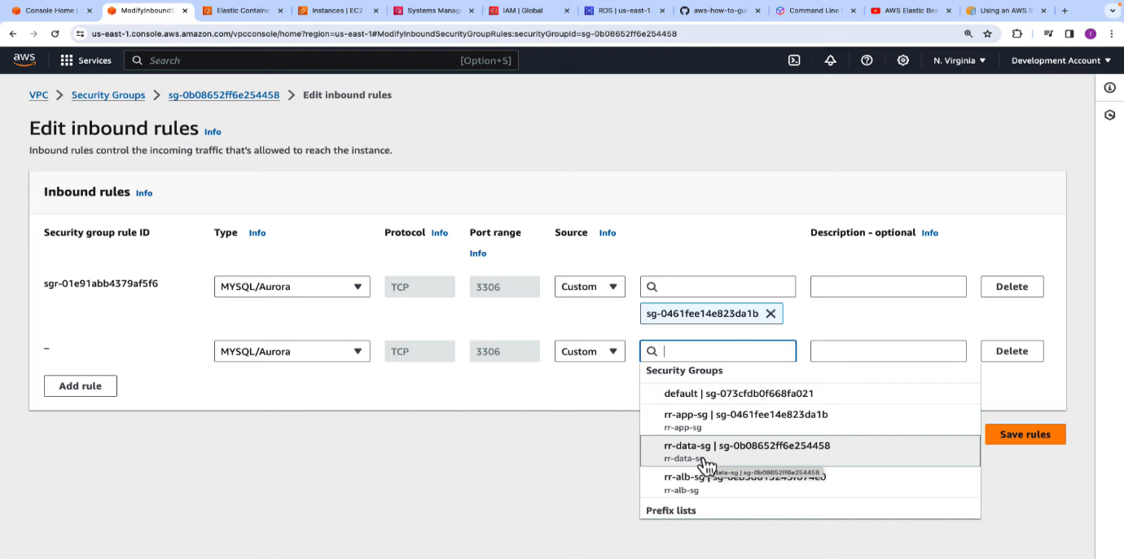

* Go to the Secret manager select (Credentials for Amazon RDS database)

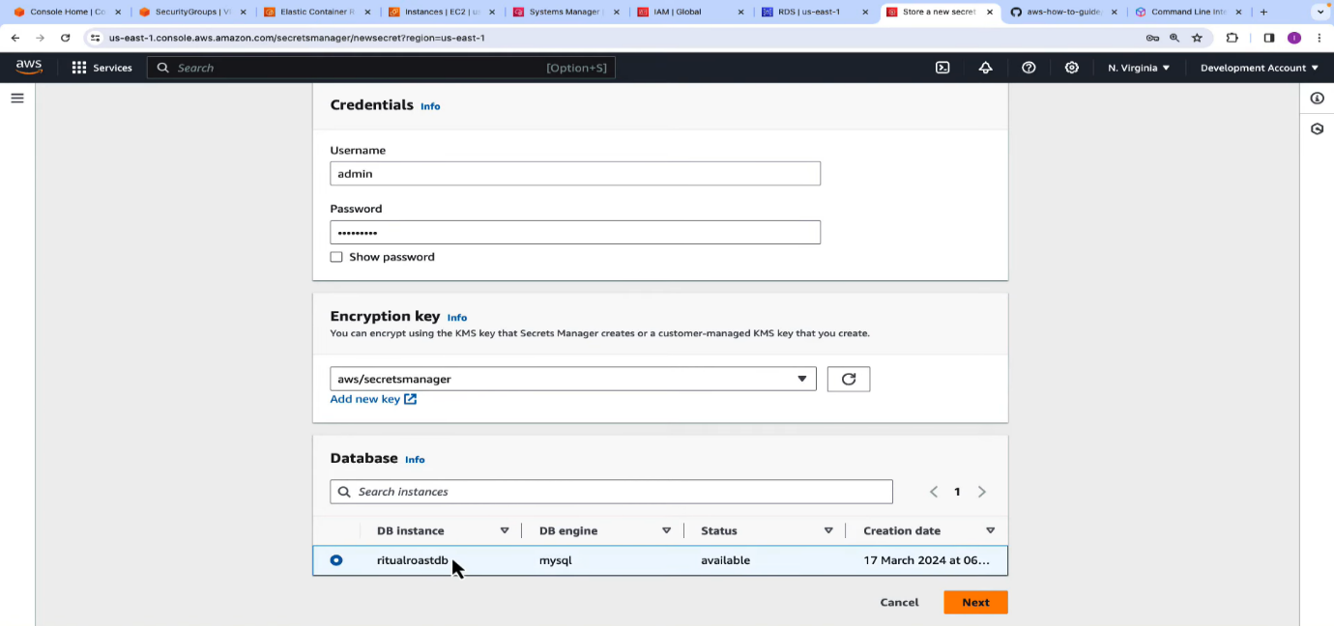

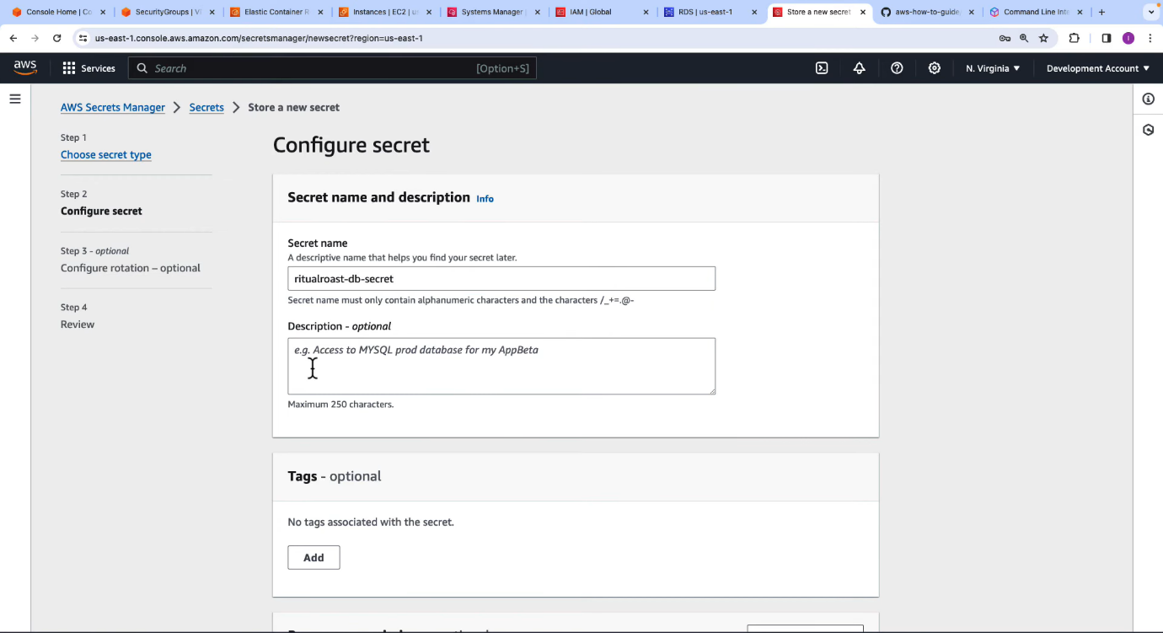

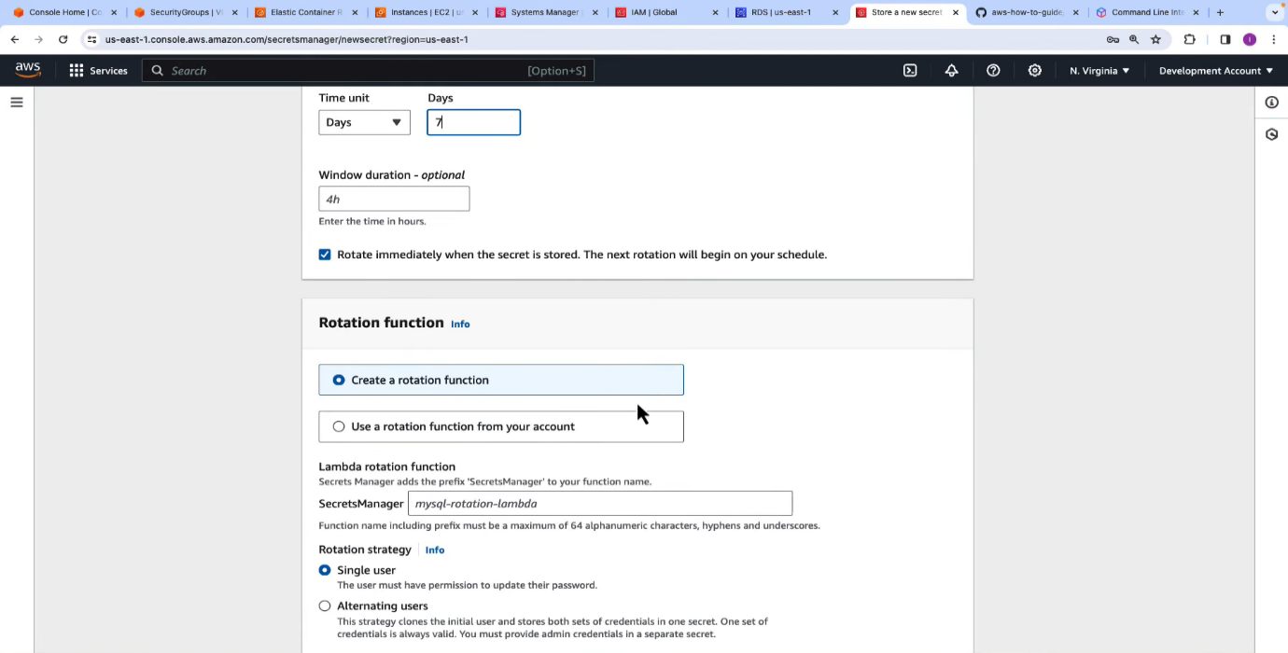

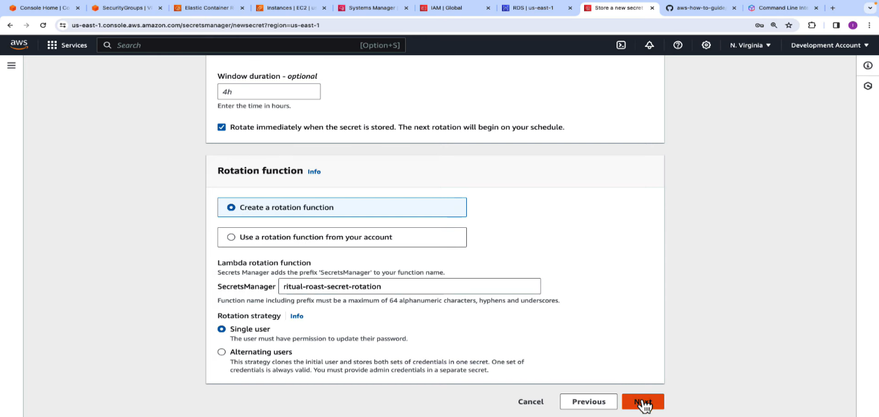

* Check in the secret manager 🡪secrets🡪Your Secret manager 🡪Rotational Configuration is “Enabled”

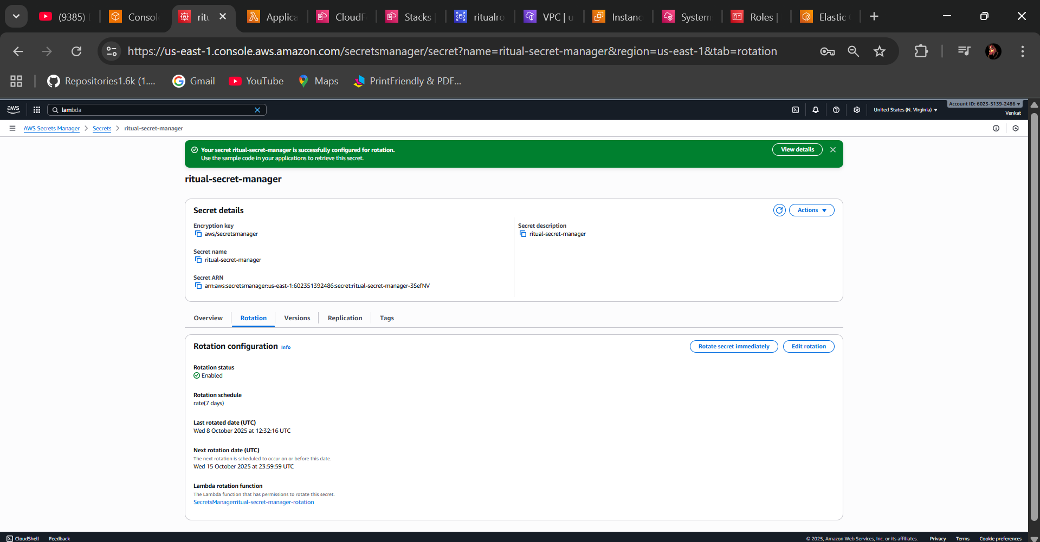

* You can notice that the files were created in the CloudFormation and Lambda Functions

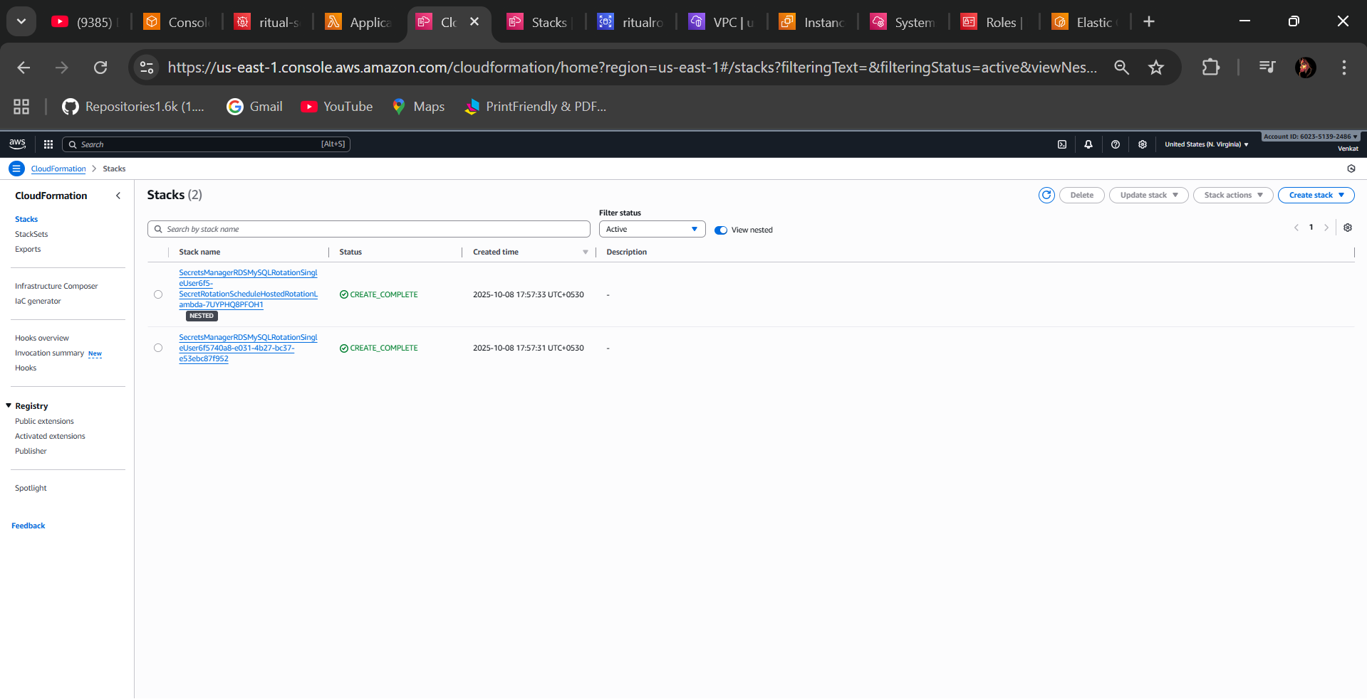

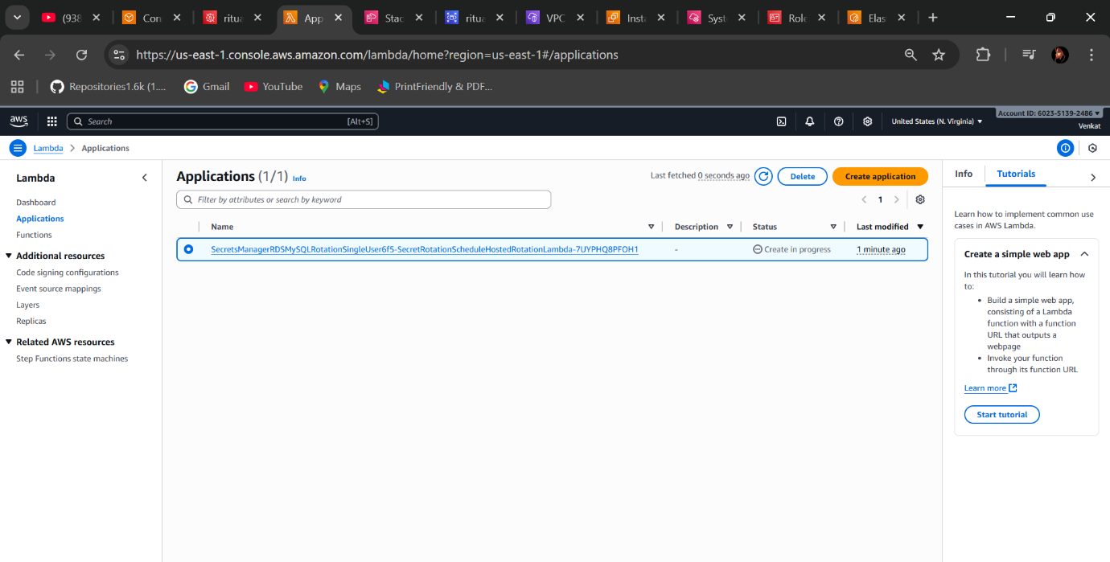

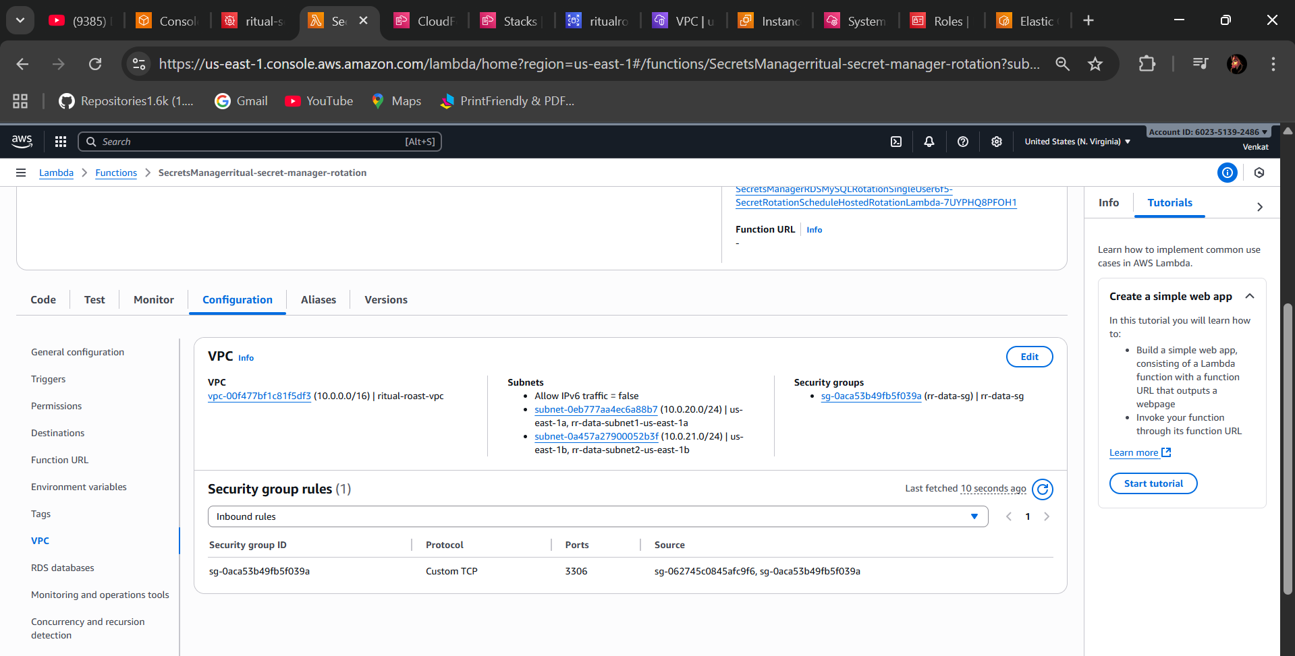

**🡺Step 7 - Create Target Group for Application Load Balancer**

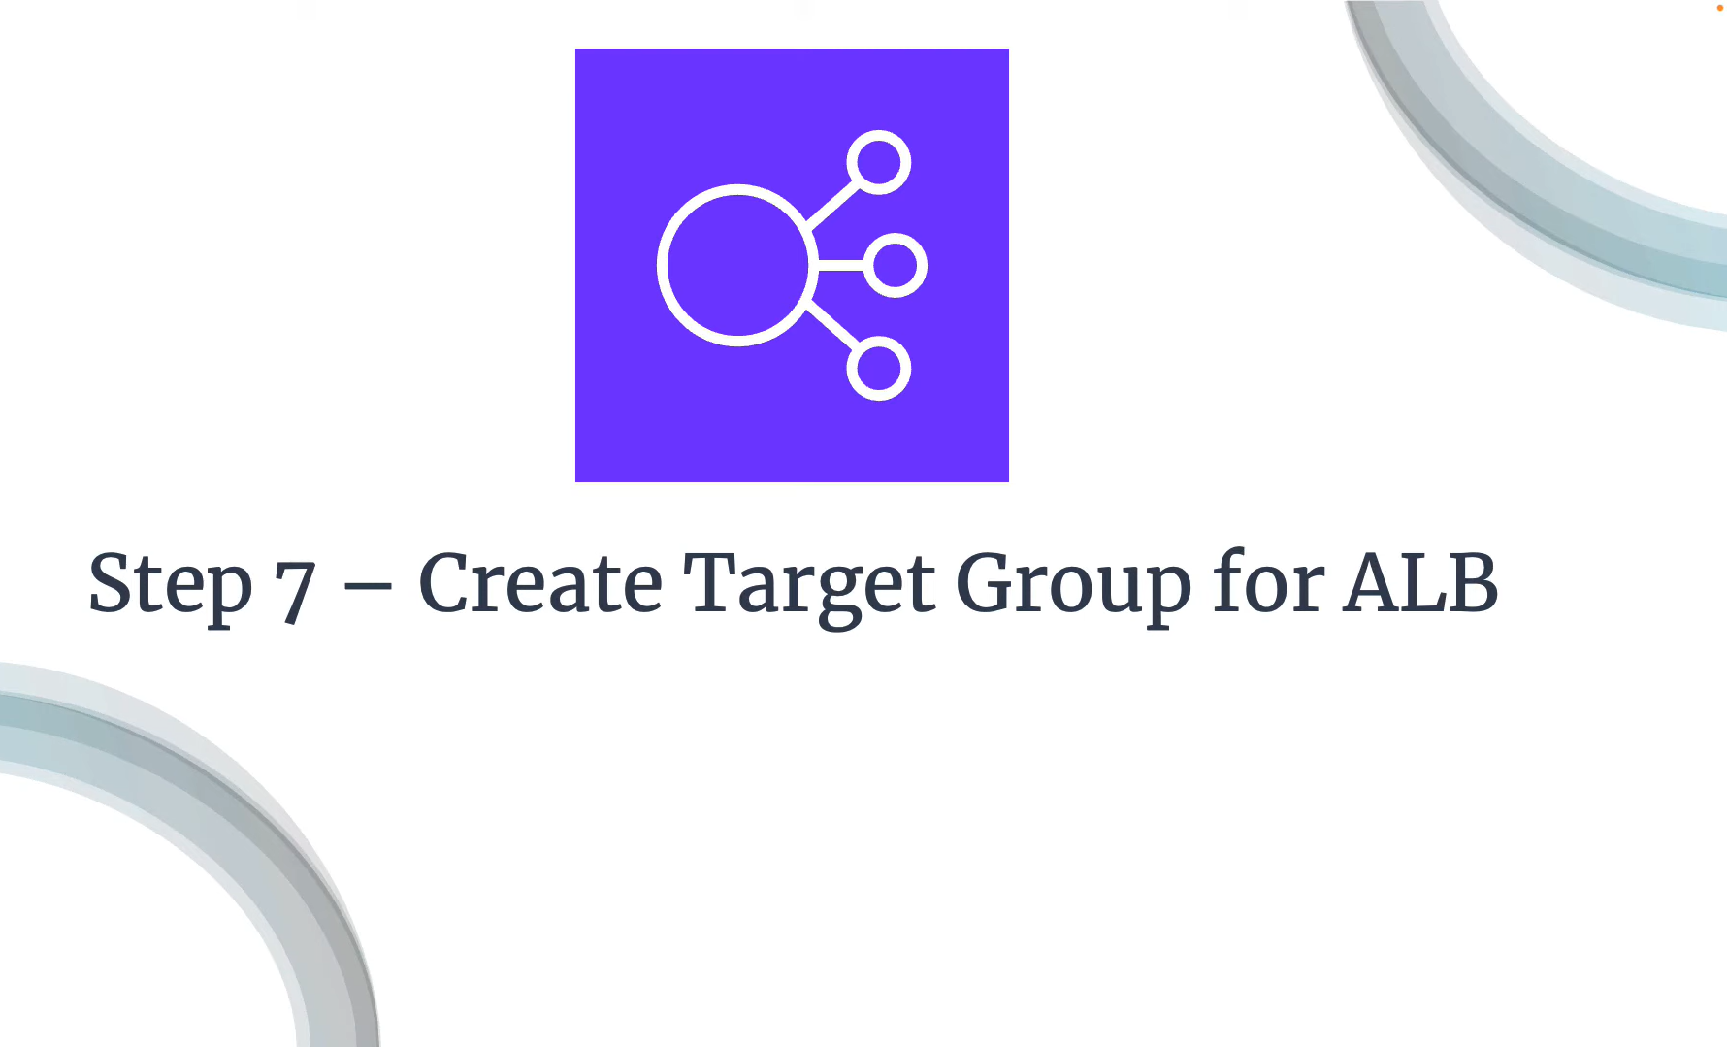

* In the Target Groups Select IP Addresses (Because we are using Fargate)
* Target Group name
* Select your VPC
* Health Checks (/health.html)

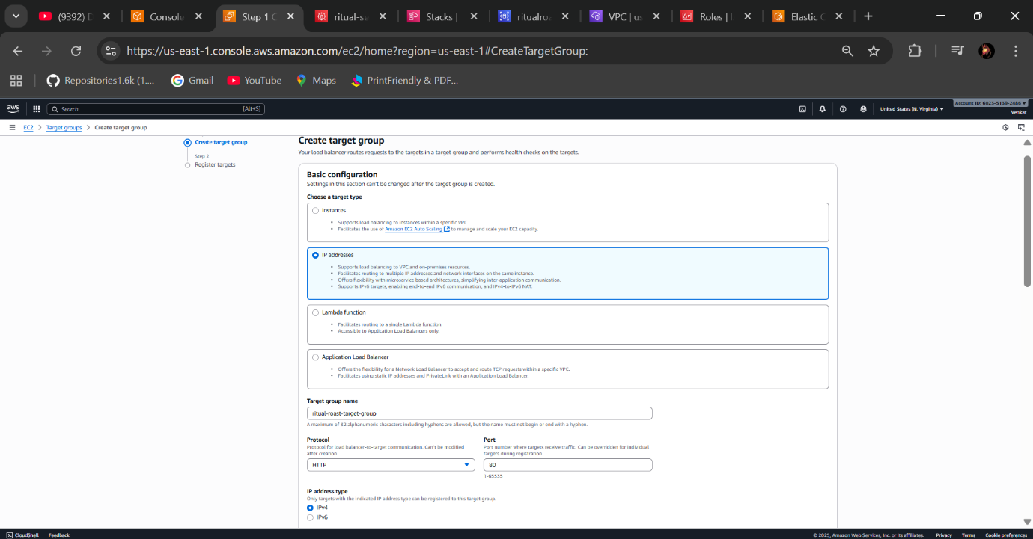

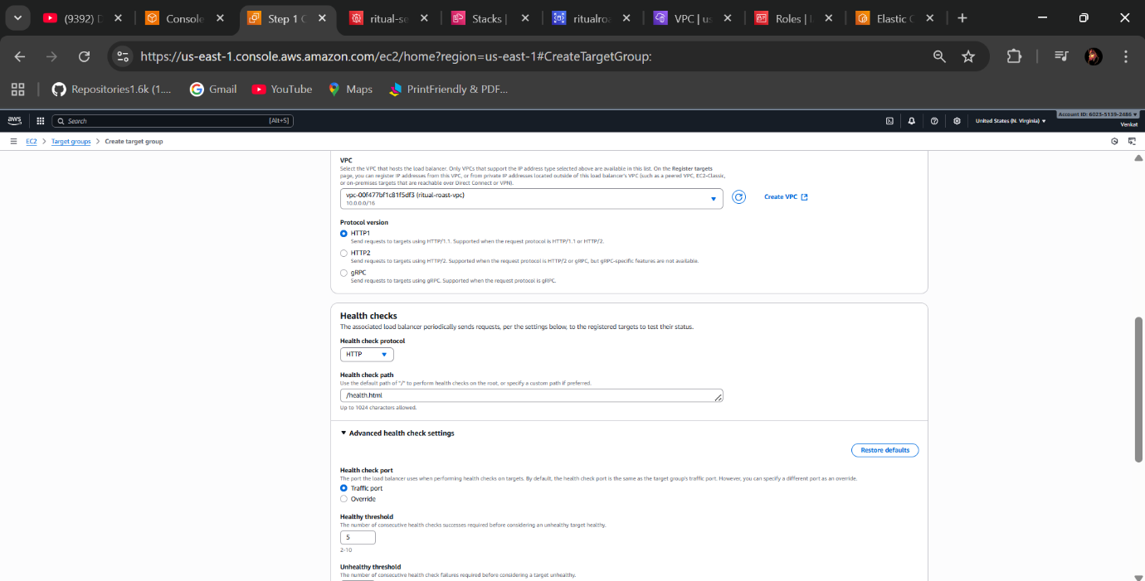

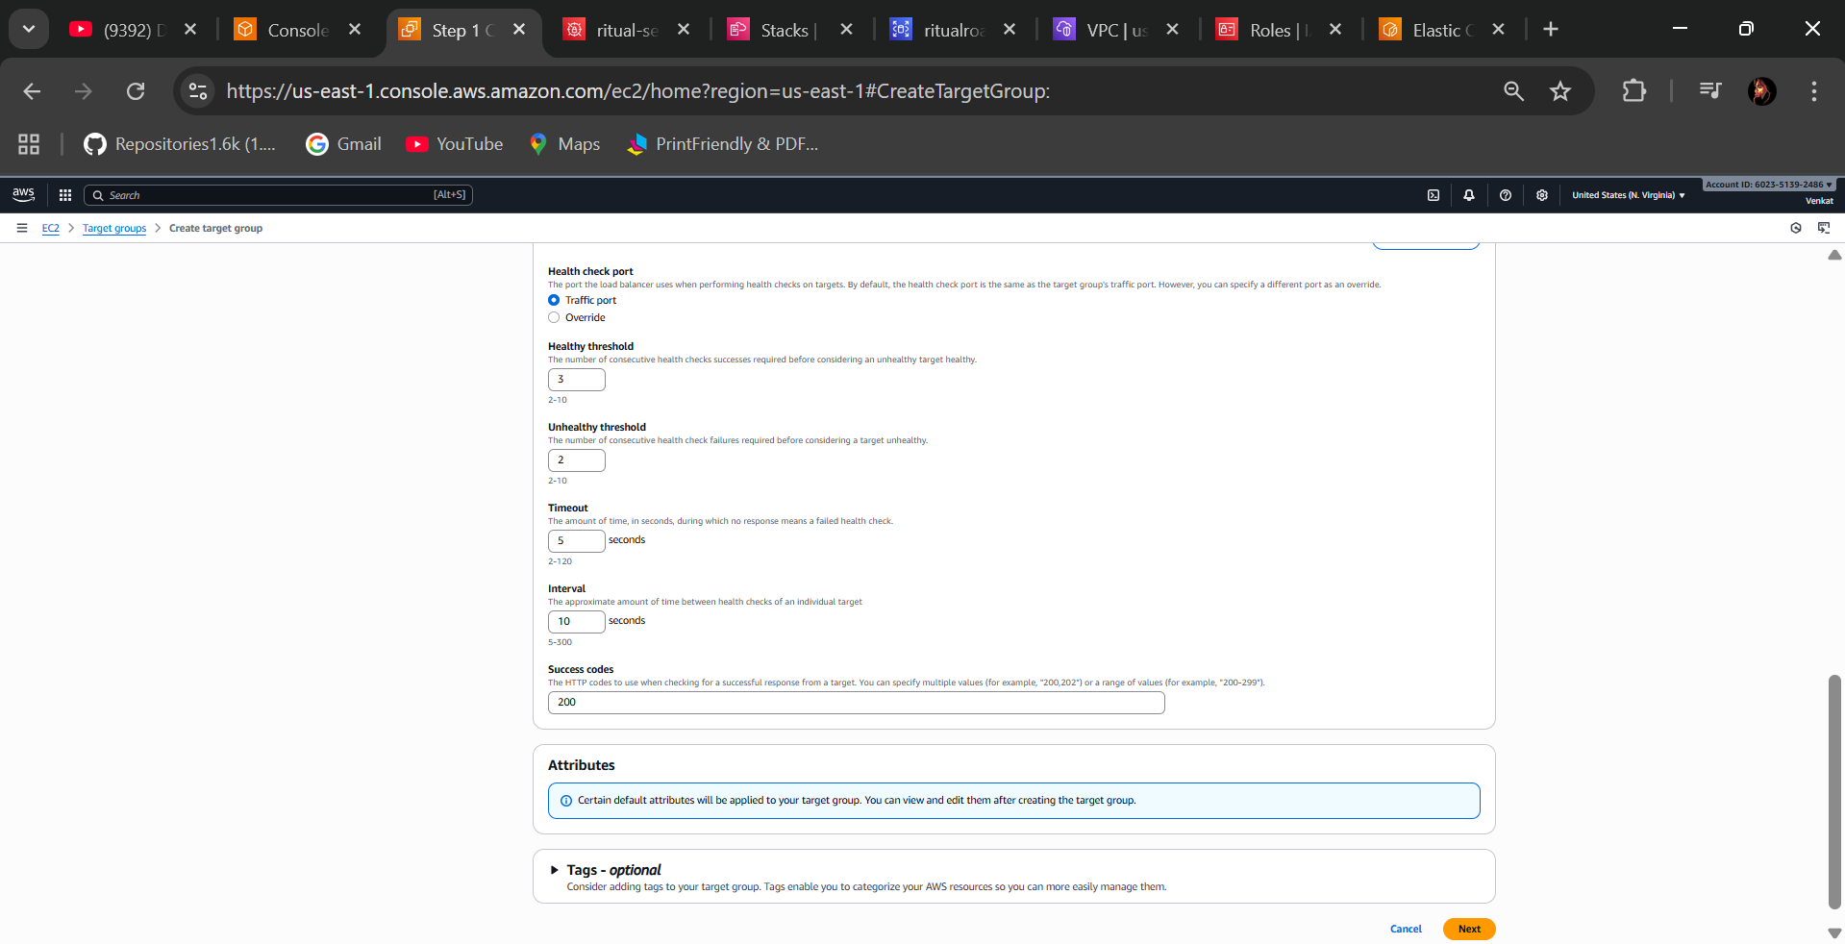

* You can modify Health checks as you wish Interval decreasing to 10 sec for practice purpose only and Next
* Select Next Target group option

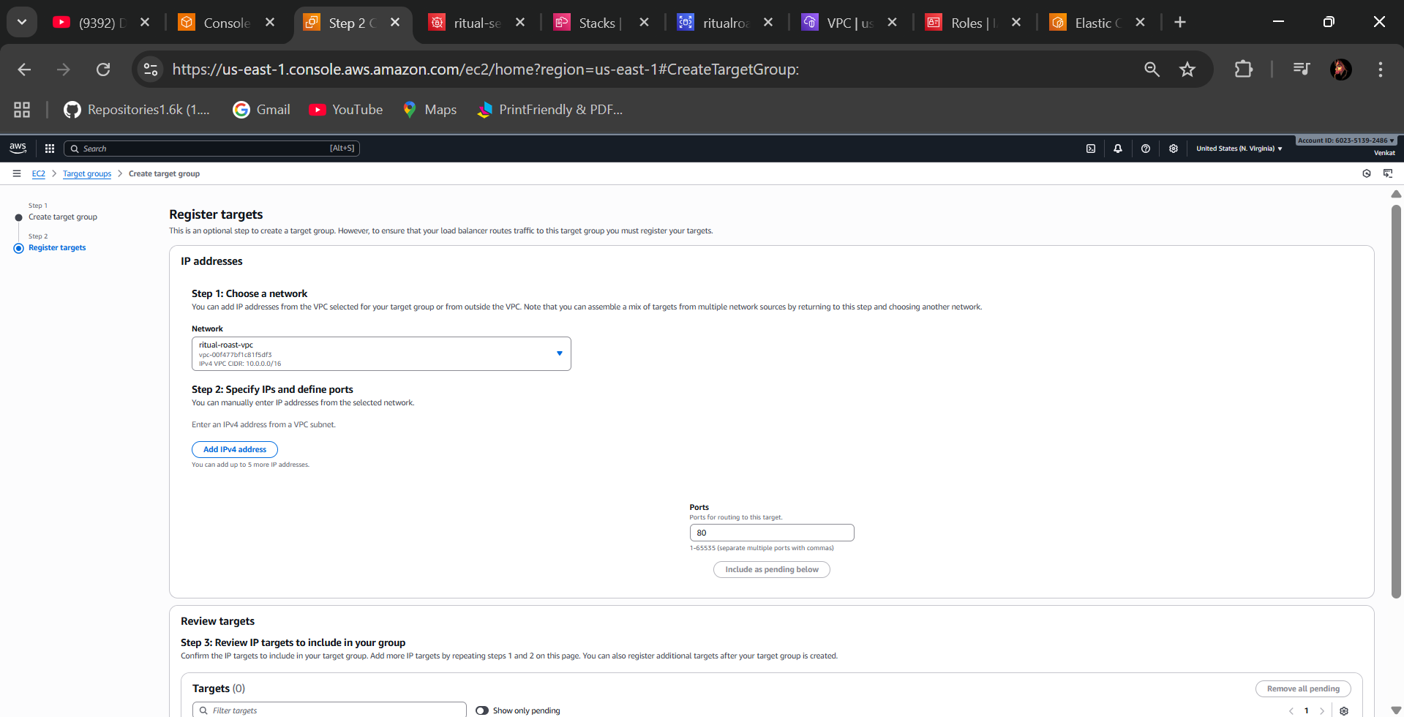

* Create Target Group

**Step 8 - Create an Application Load Balancer**

* Select Application load balancer
* Select availability zones of “public subnets”
* Select security group of load balancer you were created previously
* Select Target Group
* Create load balancer and check the status is in “Active” state

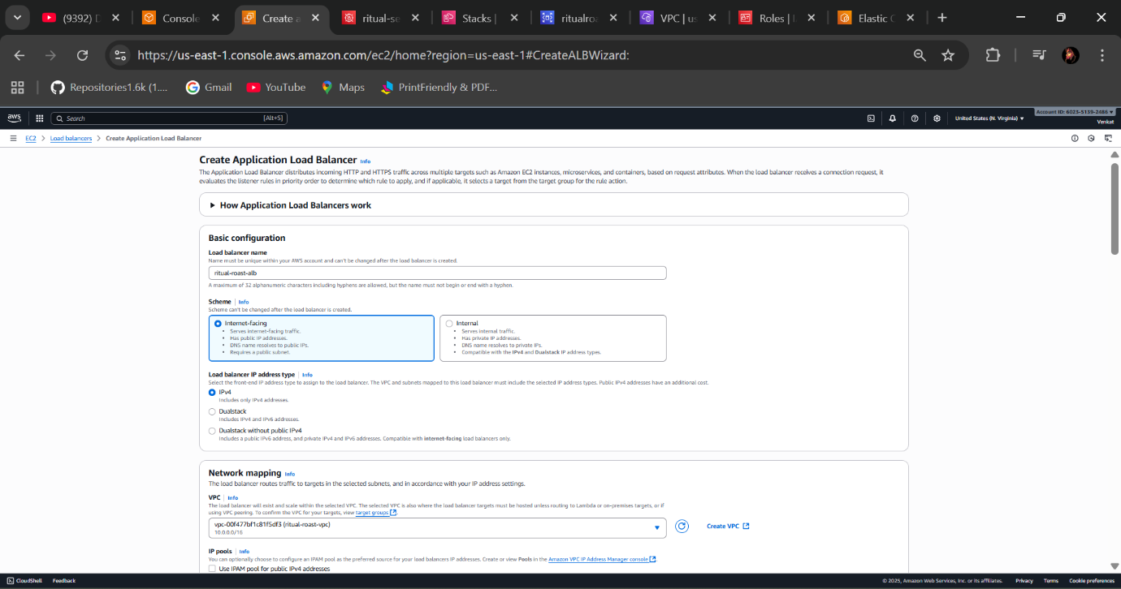

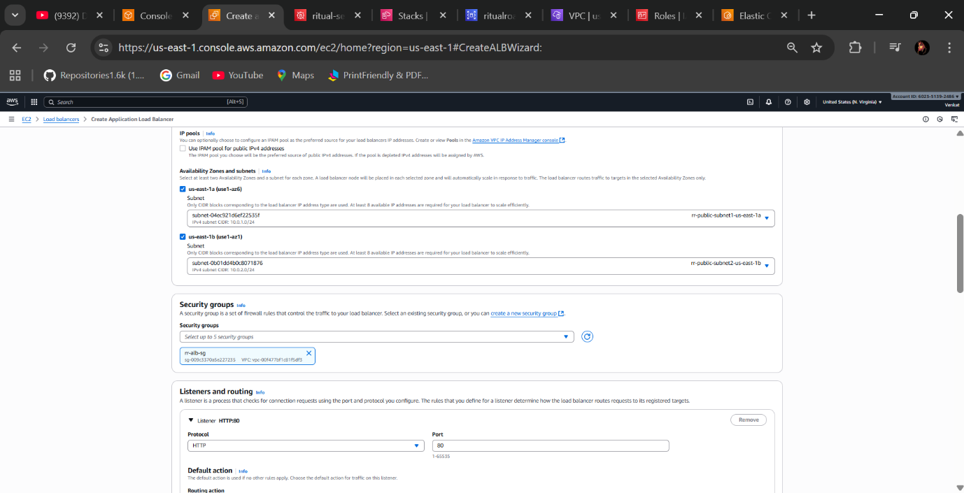

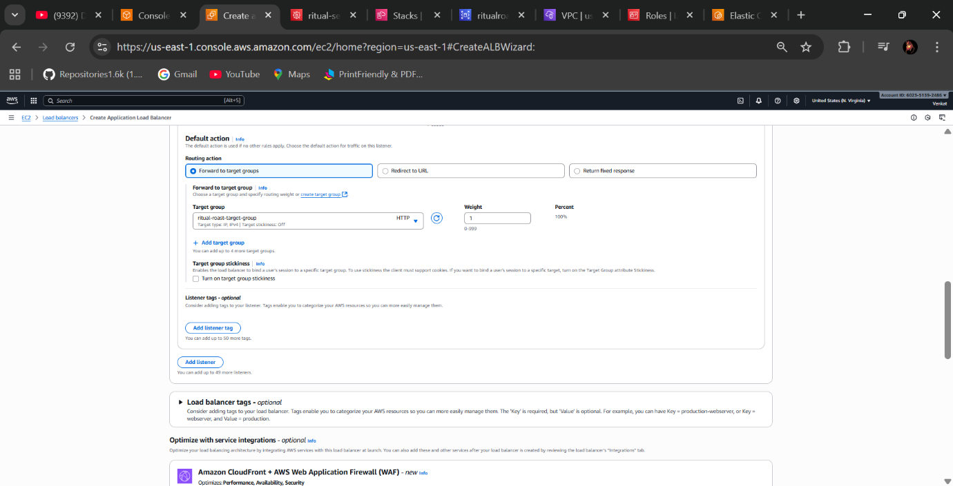

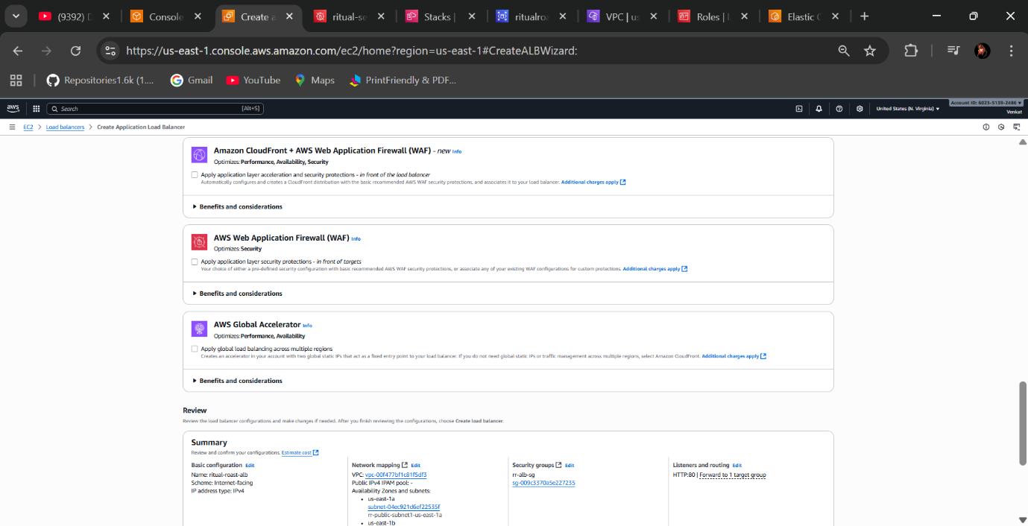

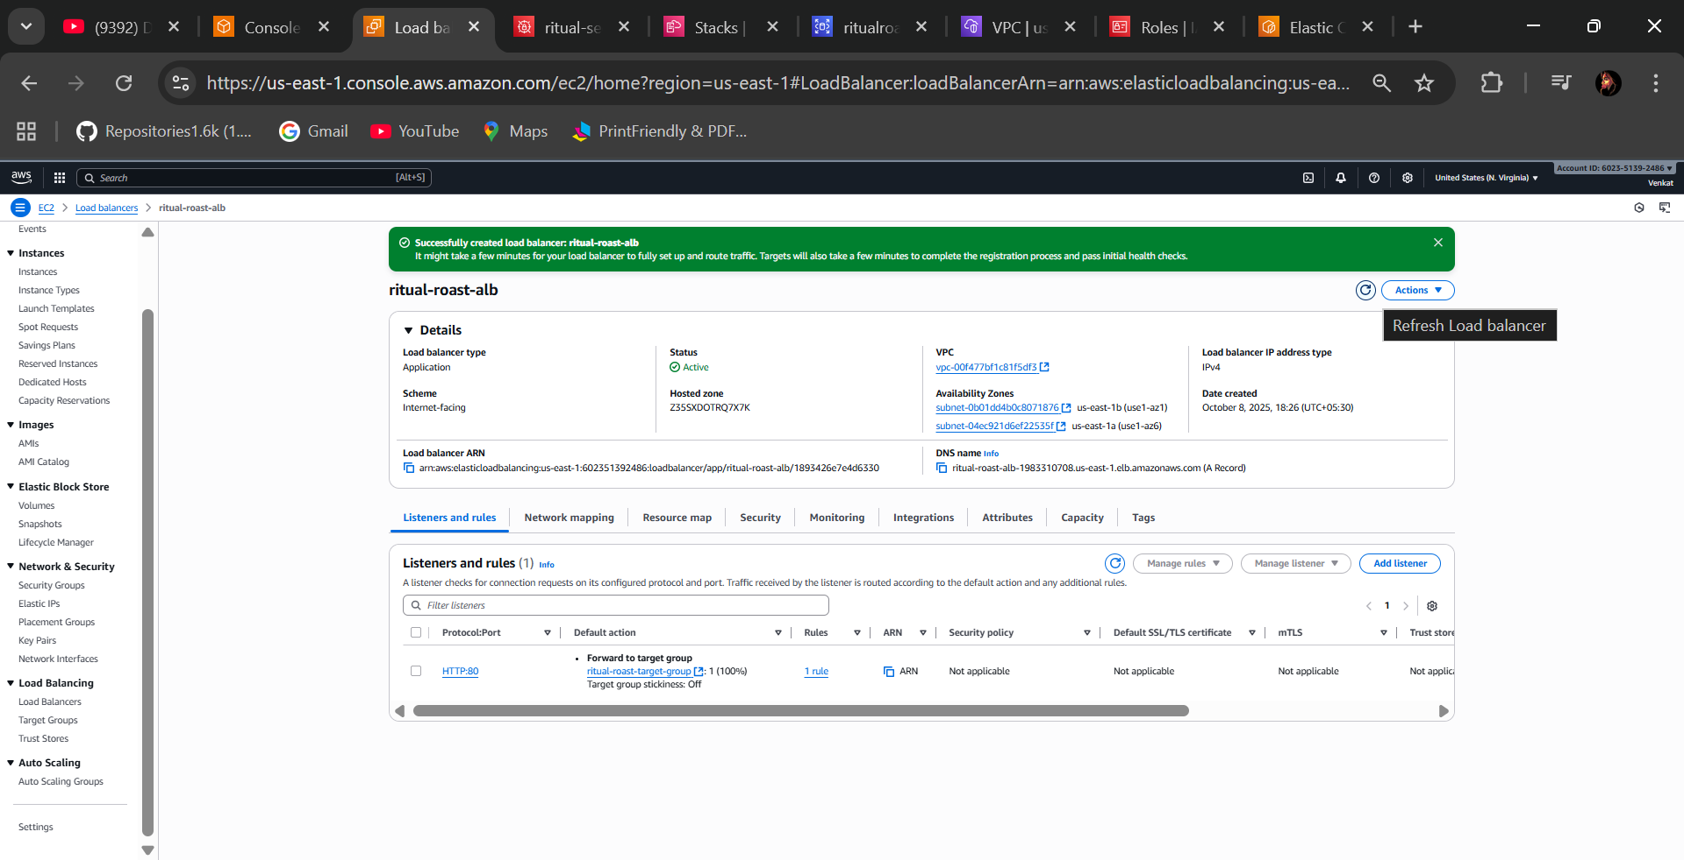

* Status is in “Active” state

**🡺Step 9 - IAM Roles and Policies for ECS Tasks**

* Go to the IAM Policies🡪 Create policy in the Secrets Manager 🡪search Select “GetSecretValue”

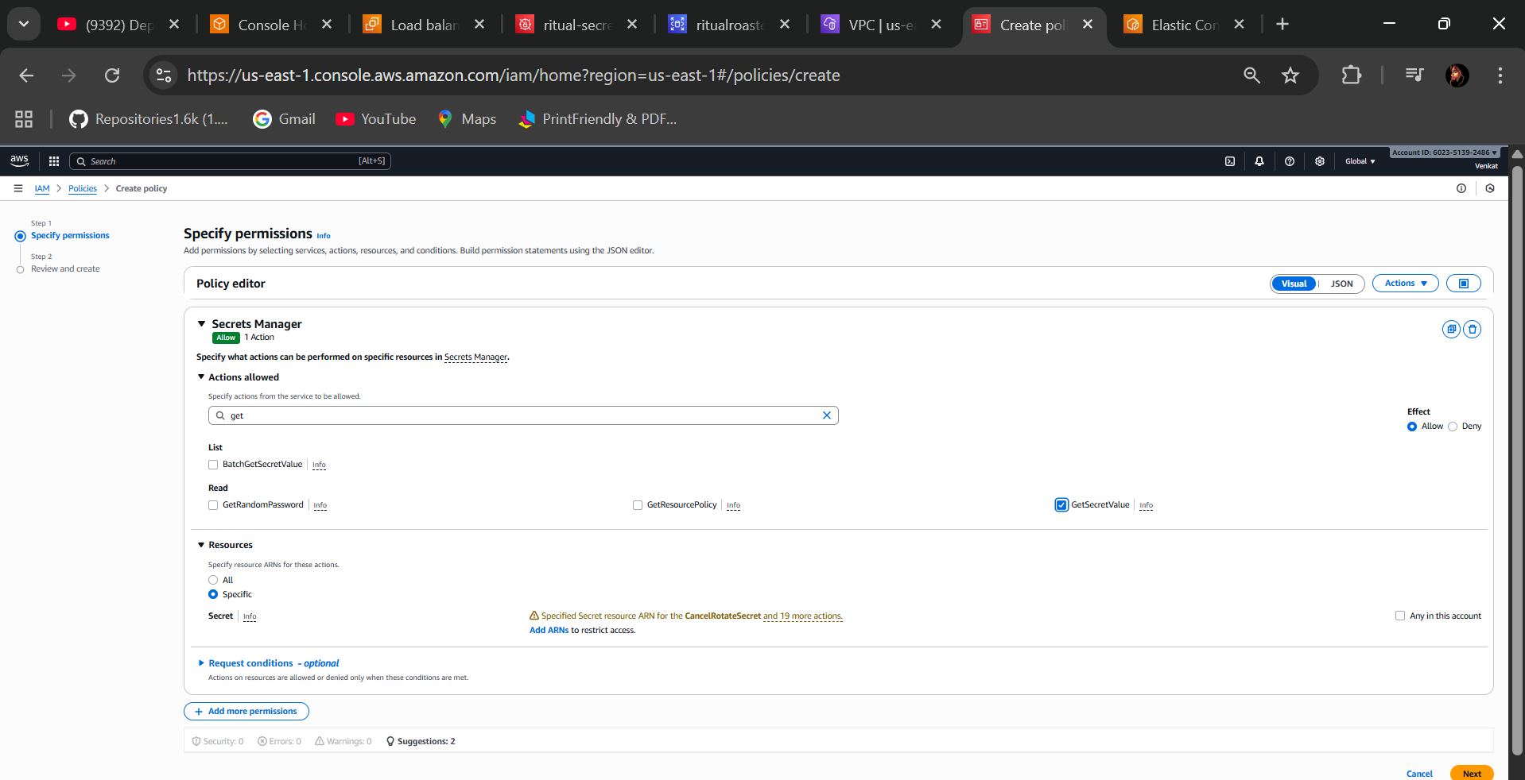

* In the Resources option select “specific” in there add ARN (Amazon Resource Name) pick from the secret manager previously created you can see the URL of Secret ARN when you paste it will pickups automatically and ADD ARN

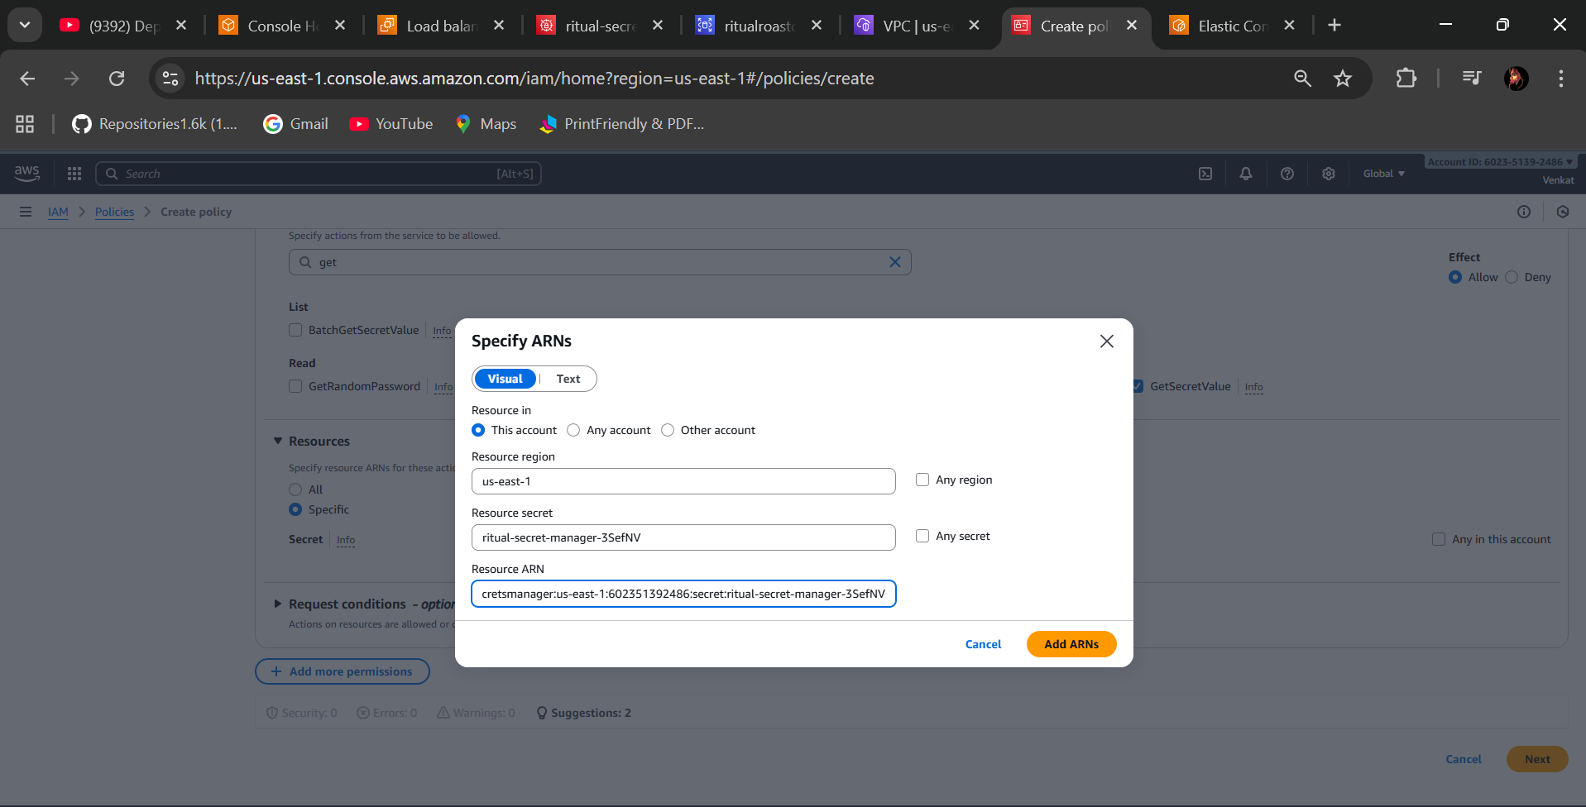

* Next Give the policy name (ritual-roast-allow-read-db-secret-policy) and create policy

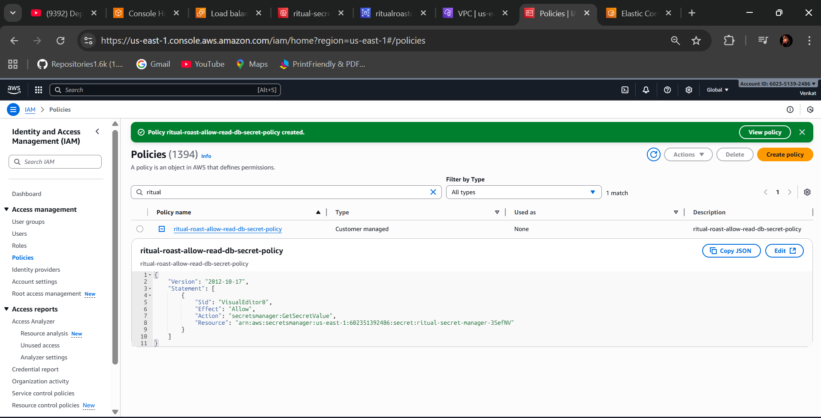

* Check your policy was created
* Next Create Role Select “AWS Service” 🡪Use Case (Elastic Container Service Task) & Next

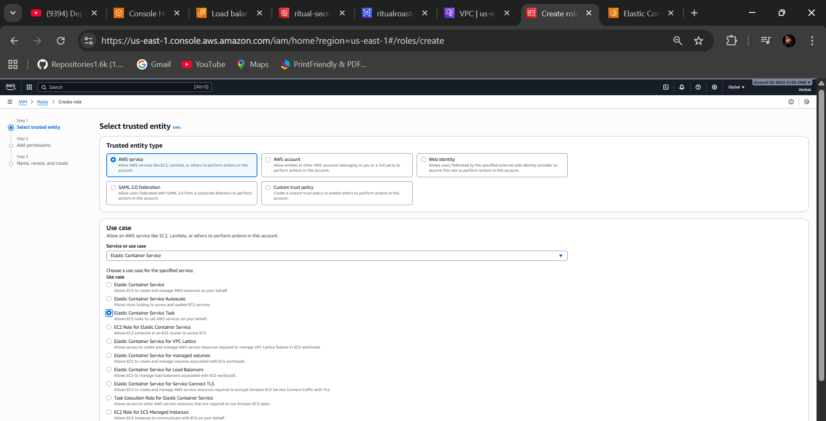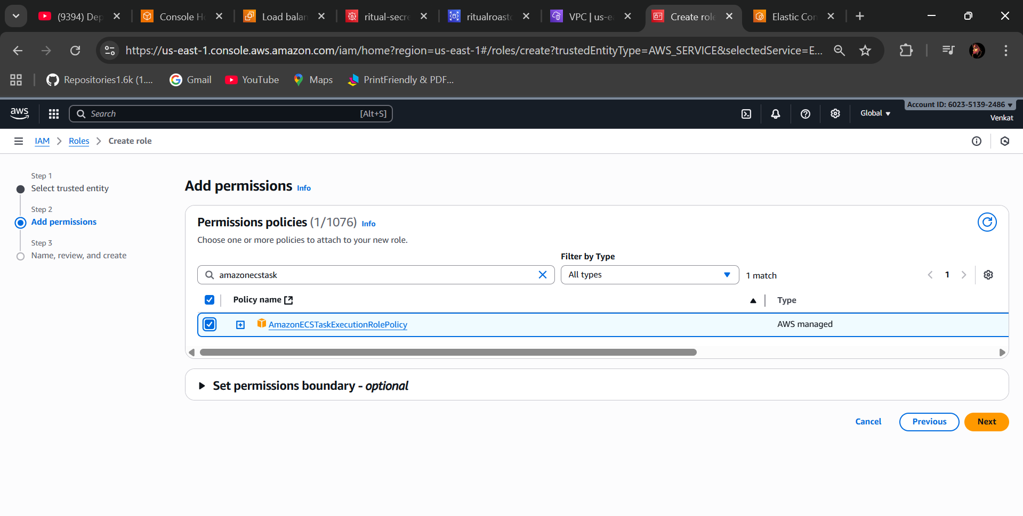

* Attach the policy to the role that is “AmazonECSTaskExecutionRolePolicy” and also select your policy previously created(**ritual-roast-allow-read-db-secret-policy)** next gave the role name (ritual-roast-ecs-task-role)

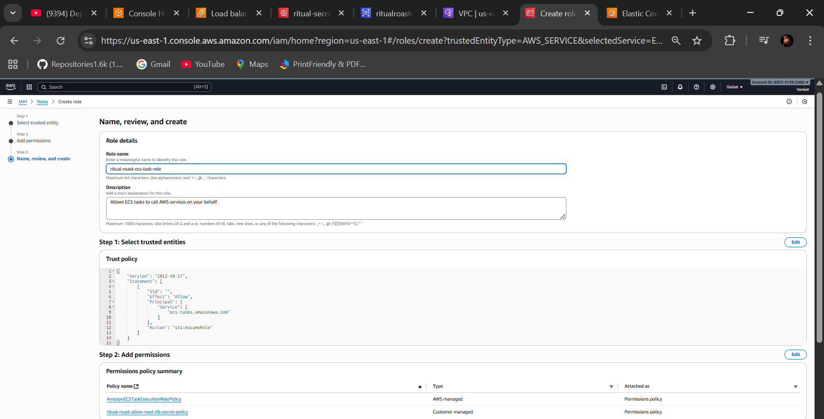

**Step 10 - Create an Amazon ECS Cluster**

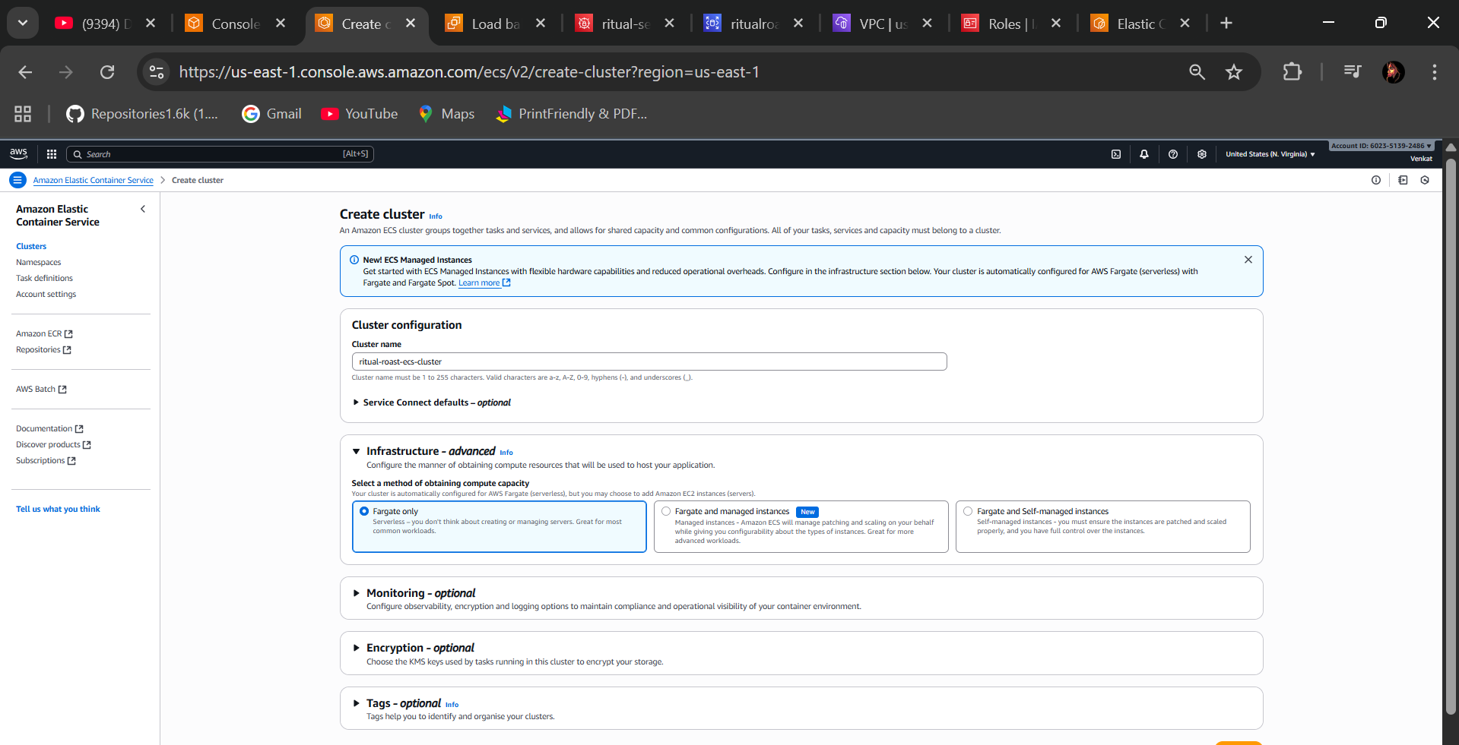

* Select AWS Fargate (Serverless) and create

**🡺Step 11 - Create an Amazon ECS Task Definition**

* In the ECS go to the Task definitions and give the name and select the AWS Fargate
* Select 5CPU & 1GB memory for practice purpose

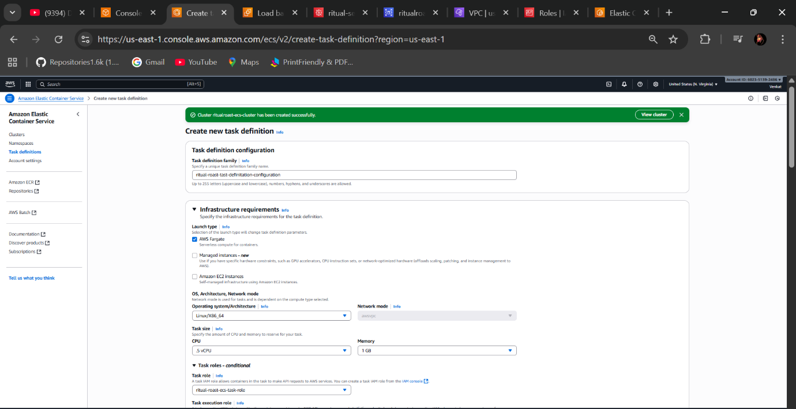

* Select Task role (ritual-roast-ecs-task-role) & Task execution role (ritual-roast-ecs-task-role) which we are created previous
* Container details name & Image URI (select from the AWS ECR URI paste there), essential container is “yes” and create

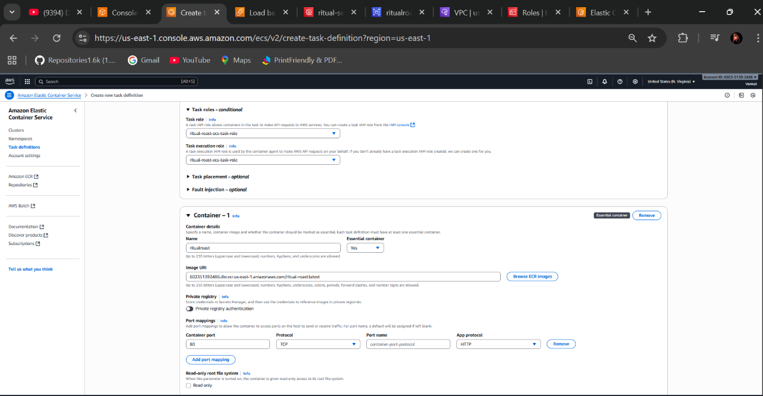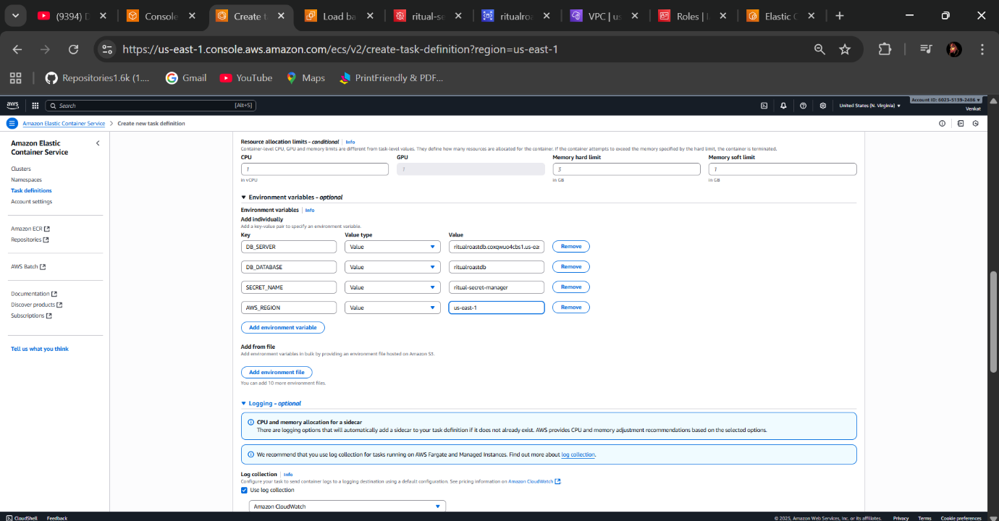

* In the Environment Variables:

Key value type Value

DB_SERVER paste <RDS ENDPOINT>

DB_DATABASE paste <RDS Database name>

SECRET_NAME paste <Secret manager name>

AWS_REGION us-east-1

* Create (Task Definition Successfully Created)

**🡺Step 12 - Create an Amazon ECS Service**

* Create ECS Service go to the AWS ECS in the Cluster 🡪Go to you cluster and create service there In Create service select your “task definition family” it will automatically pop-up there and give service name
* Environment select “Launch type”, Fargate, Latest
* Deployment configuration select “replica” desired tasks is 1
* Deployment strategy is “Rolling update”
* In the Networking select your VPC, subnets (rr-app-subnet1 and rr-app-subnet2)
* Select existing security group (rr-app-sg)
* Public IP Turnoff
* Select your Load balancer “Application Load balancer”
* Select your existing Listener
* Select your Target group
* Autoscaling min 1 and max 2
* Select “Target Tracing”, Policy name (ritual-roast-autoscaling-policy)
* ECS service metric “ECSServiceAverageCPUUtilization)
* Target value 70, scale-out & scale-in 300
* Create
* You will see the ECS Service is Deployed successfully

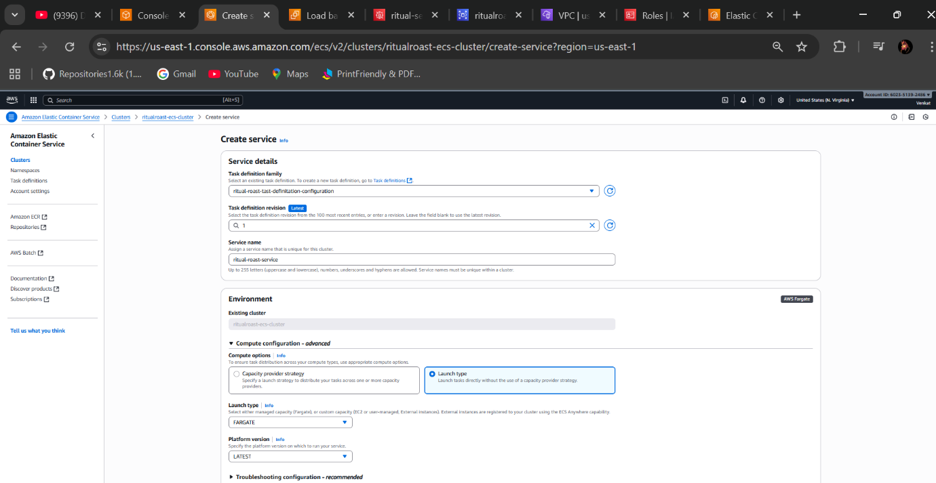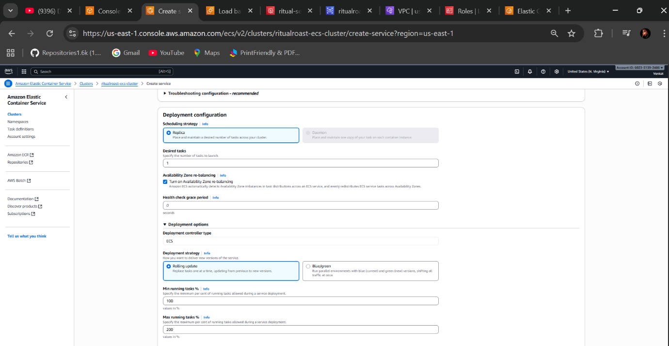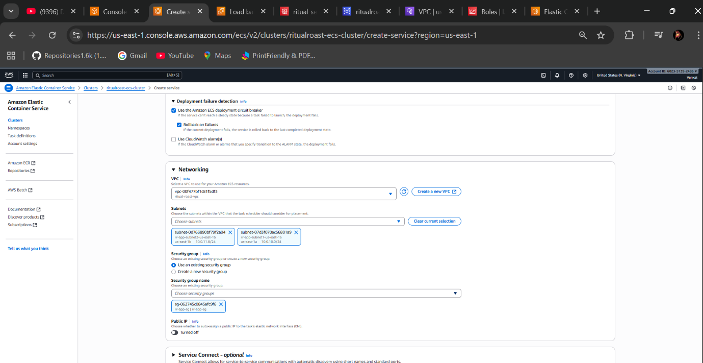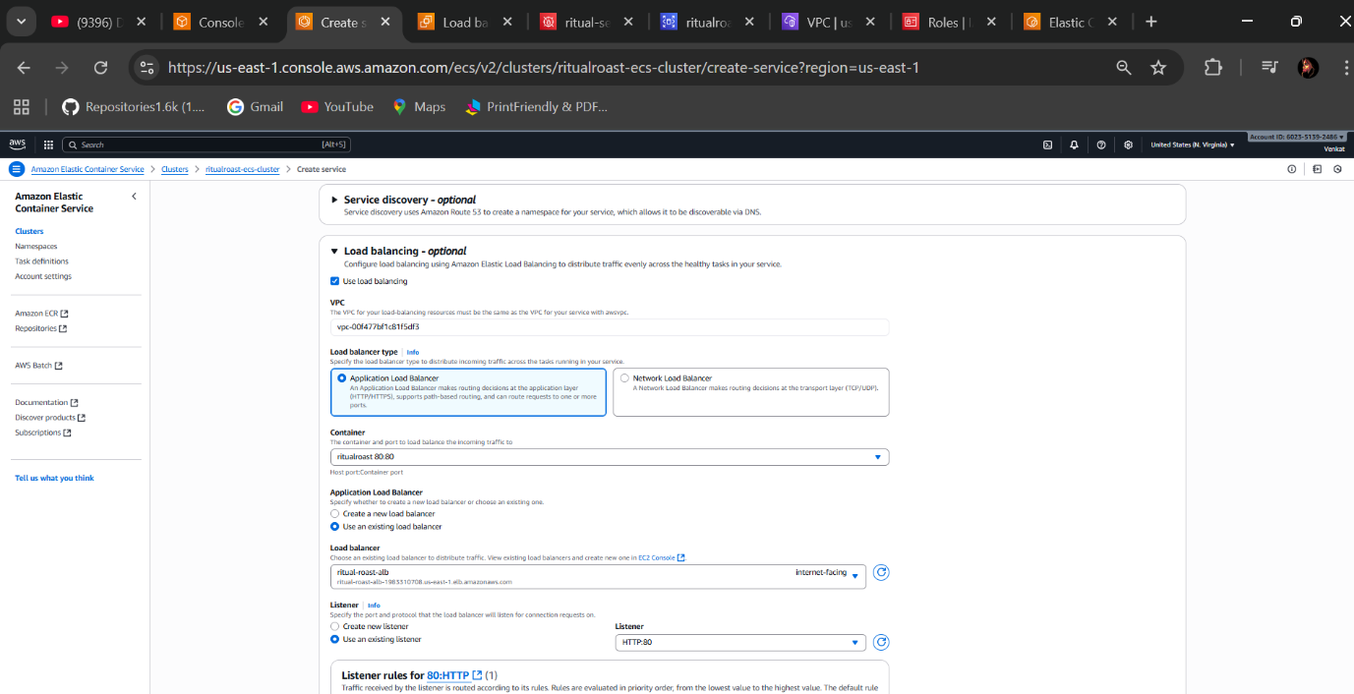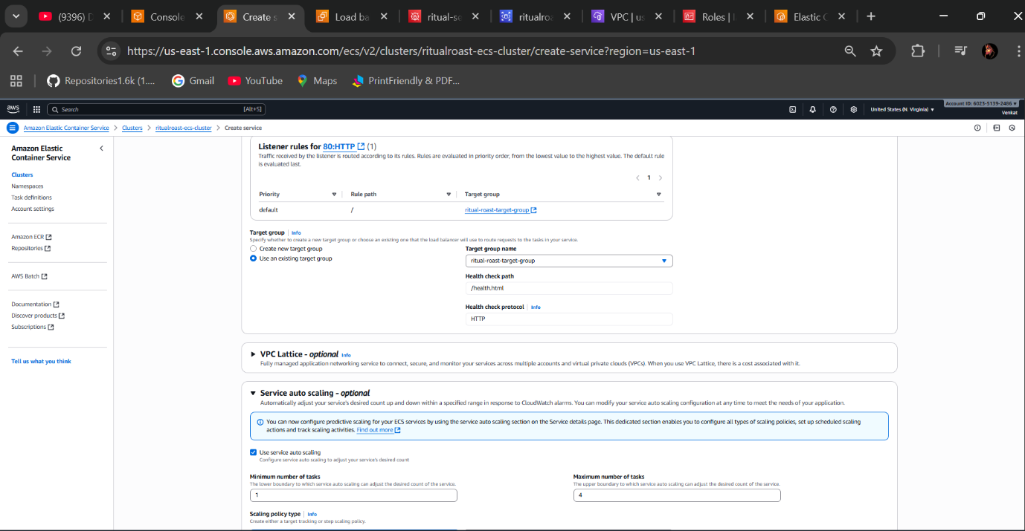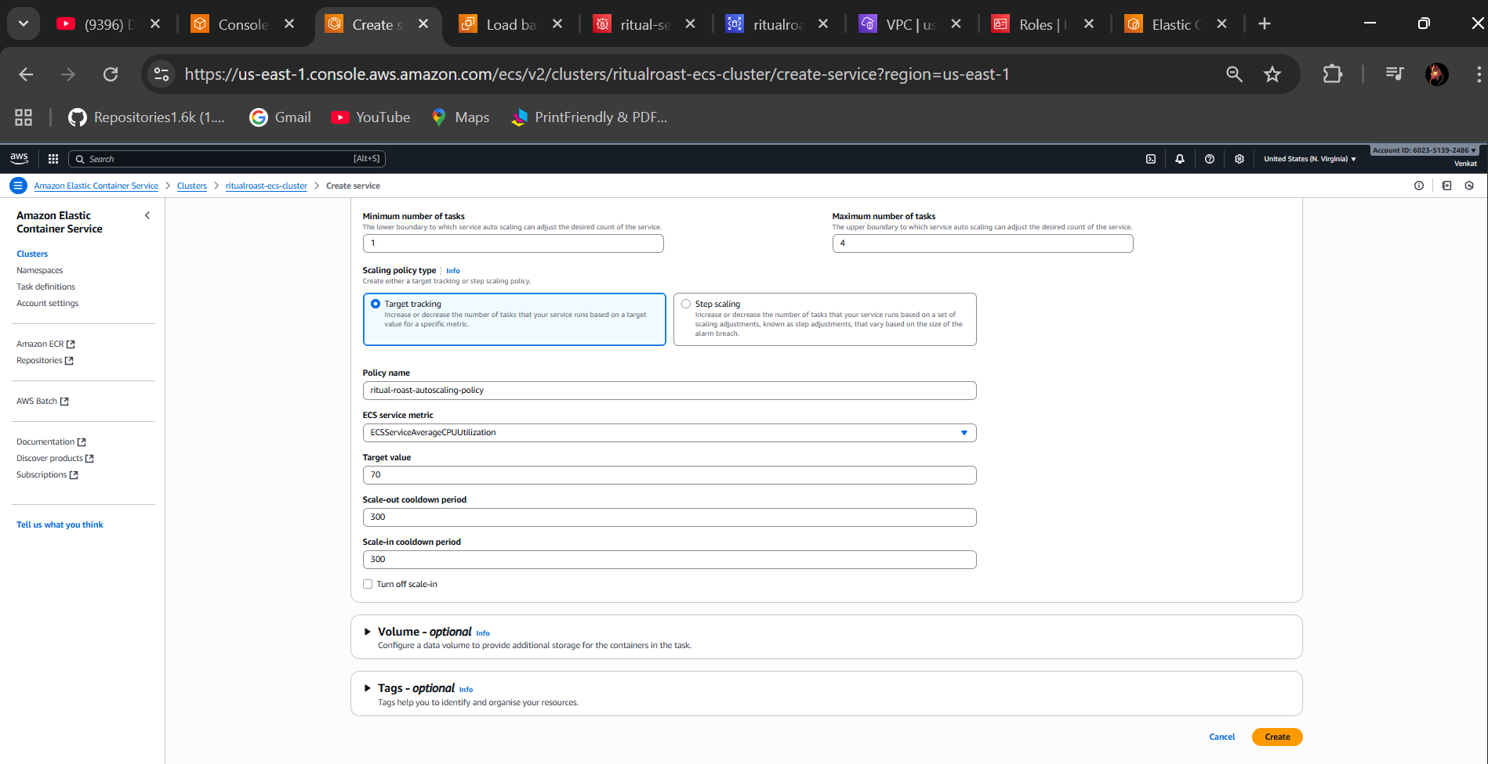

* Check the service is 1/1 task running is in Active status, Tasks is running
* Check go to the load balancer target group their healthy state is 1 and unhealthy state is 0

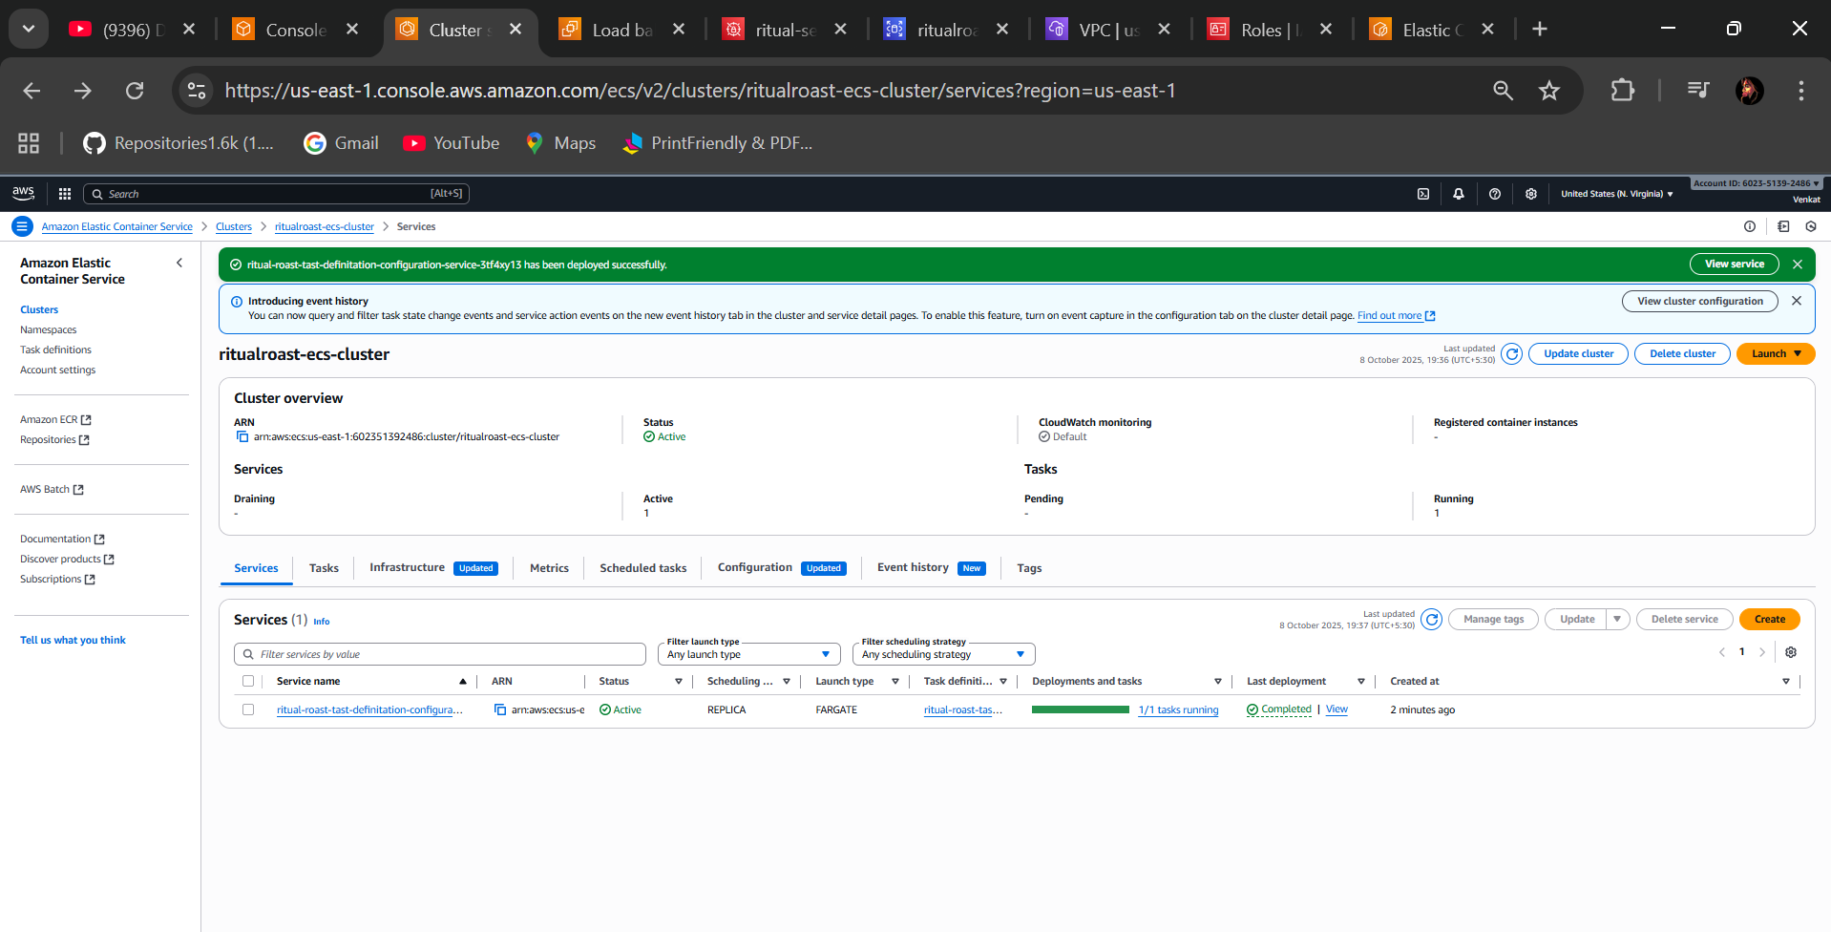

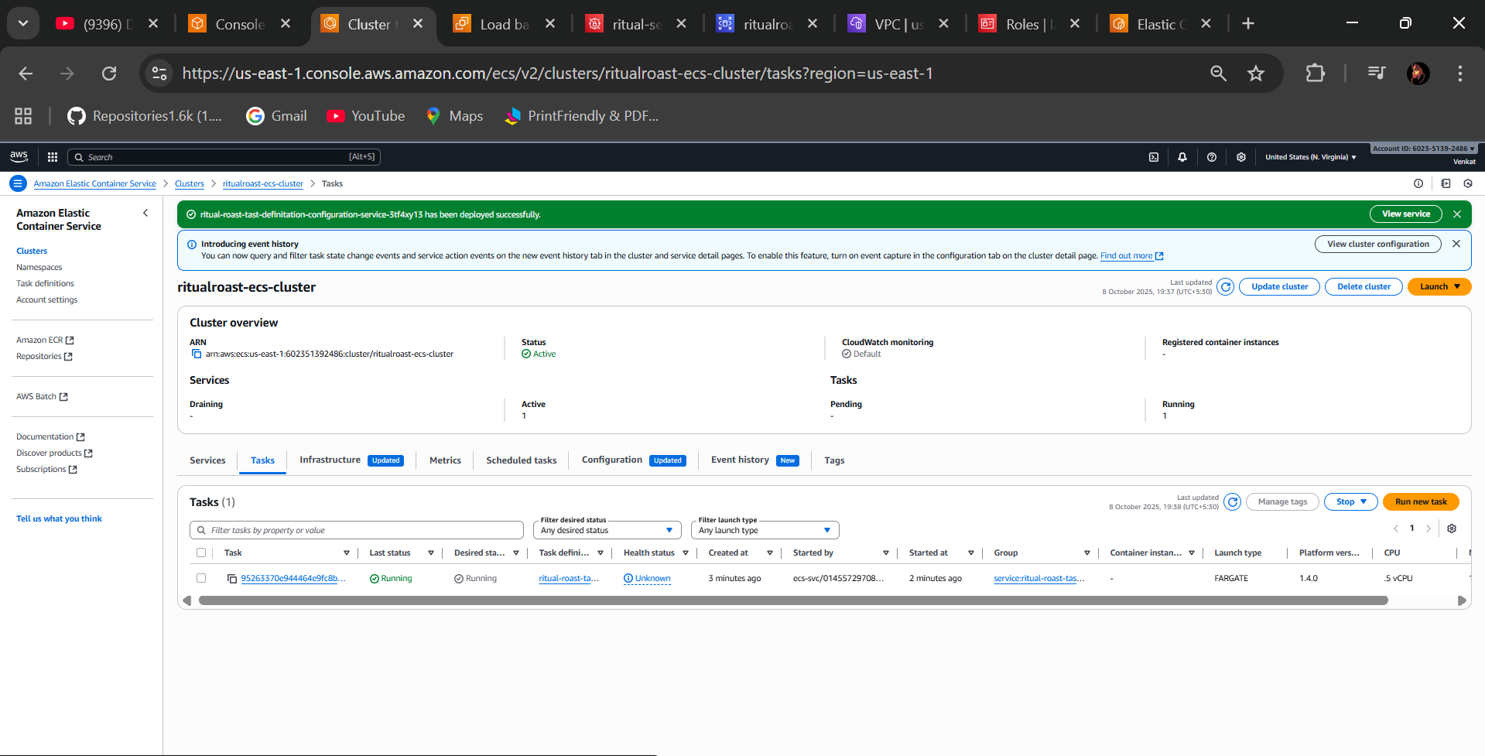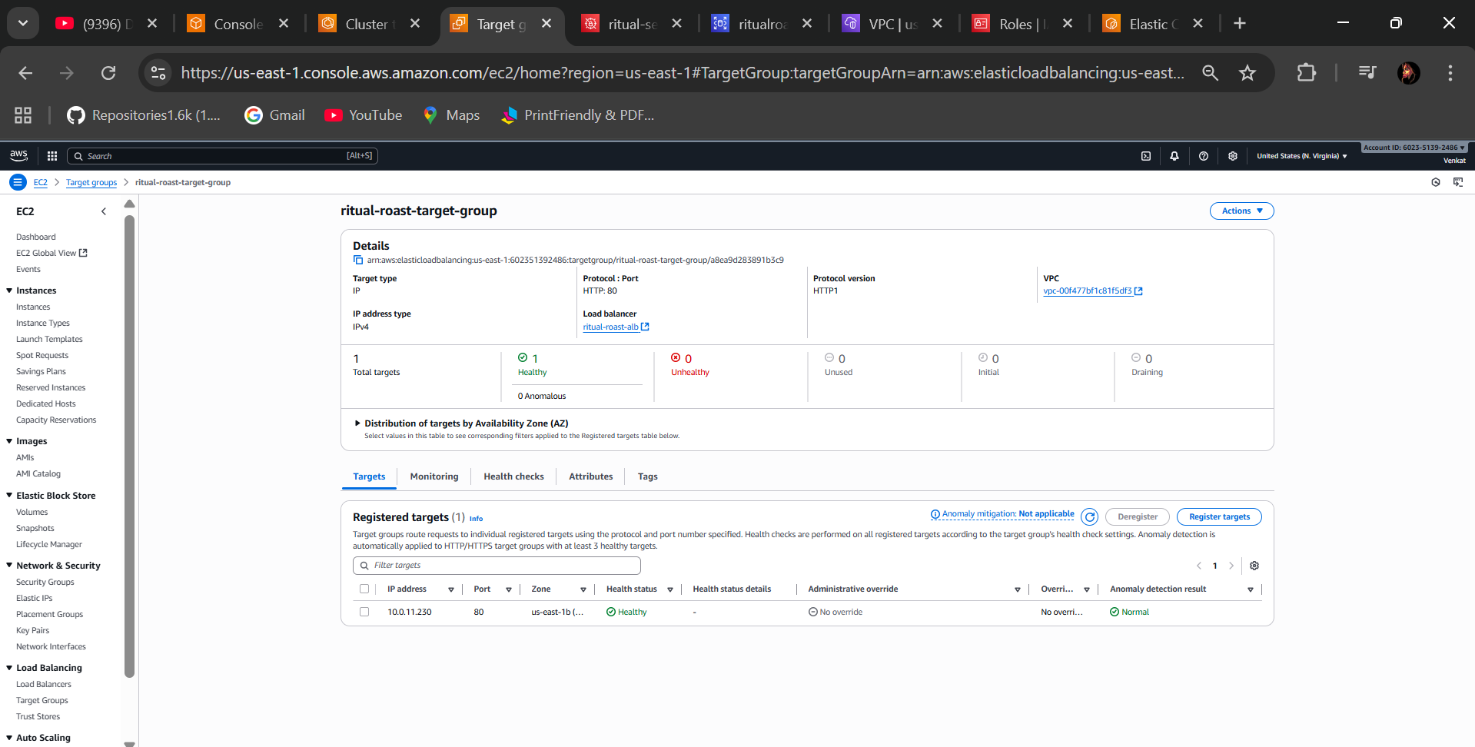

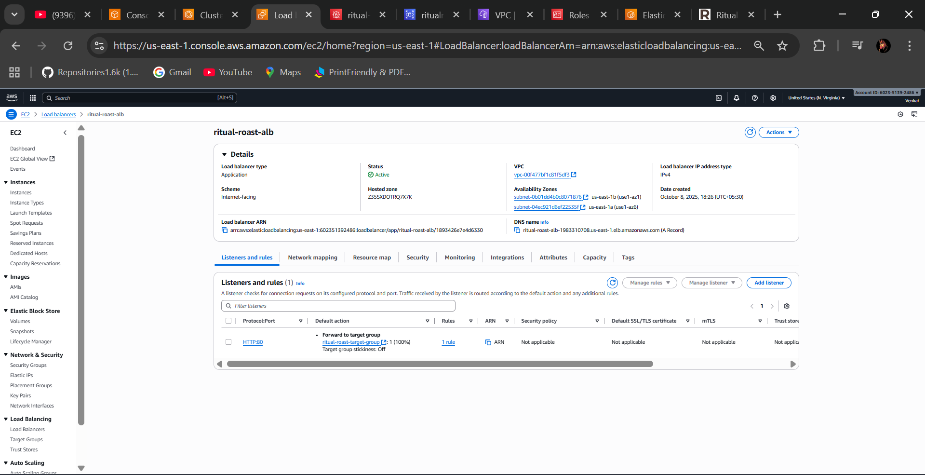

* Go to your Load balancer Take DNS name and paste in the browser to check it working successfully BOOM.

**Output:**

